Populations: The Hare and the Lynx
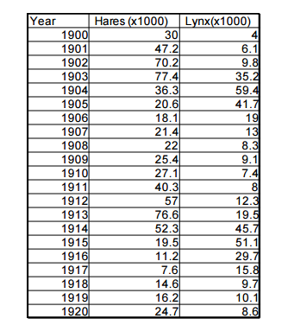
Populations are always changing. Sometimes changes are the result of humans interfering with food webs or habitats. But even when humans do not interfere, populations will still naturally shift up and down or fluctuate. For example, let us study the relationship between the Canada lynx and its primary prey, the snowshoe hare. To understand how the population of lynx and hares changes year to year, we need to collect information about the number of individuals in a population. Unfortunately, it is impossible to count the exact number of hares in Canada in any given year. Therefore, this information must be gained by capturing a small number of individuals and then estimating the actual number out in the wild. For over 300 years, the Hudson Bay Company has been involved in the fur trade in Canada. Detailed company records list the number of snowshoe hare pelts and the number of lynx pelts collected by hunters and trappers every year since the late 1700’s. A small sample of this data is presented in the table below.
1. Graph the data, use one color of pencil to graph the number of hares trapped each year between 1900 and 1920. Using another color, graph the number of lynx trapped. Make sure you label both axes and include a title.

2. How does the hare carrying capacity influence the carrying capacity of the lynx population? How does the lynx carrying capacity influence the population of the hares?
3. a) What type of feedback loop does this relationship demonstrate?

b) Convert the graph into a feedback loop diagram in the space to the right.

Hares: First, let’s think about the hares. Scientists observe that as the hare population gradually increases, they eat more and more grass and seeds each year until the food supply, particularly during the winter, become scarce. At that point, young hares have a difficult time finding enough food to survive and fewer babies are born. On your graph, label these periods of hardship with arrows by using the word “hardship”. Include a short description of what is happening in your own words.

4. Name 2 limiting factors that affect the hare population.

5. As the number of hares decreases, what do you think happens to the population of grass and seeds that the hares eat? Why?

6. a. After a few years, the hare population begins to increase. Why?

b. On your graph, label these periods of prosperity with arrows by using the word “prosperity”. Include a short description of what is happening in your own words. Now, let’s think about the lynx which eats the snowshoe hares.
Lynx: 7. In general, are there more lynx or more hares? Why?

8. Do the peaks in the lynx graph line up exactly with the peaks in the hares graph?

9. a. When the hare population increases, what happens to the lynx population? Why?

b. On your graph, label these periods of prosperity with arrows and a short description of what is happening in your own words.
10. Look at 1903 and 1904. Think about what is happening to the hares at this time. Is the presence of more lynx helping the hares or hurting them? Why?

When the hare population declines, the lynxes compensate by switching to other prey such as squirrels, gophers, mice and other rodents. However, while there is other prey around, there is not enough to support a large lynx population. When females are in poor condition, fewer will breed and not all of those bred will produce litters. Litters will be smaller, and most, if not all, of the few kittens born will die soon after birth. On your graph, label these periods of hardship with arrows and a short description of what is happening in your own words. Check to see that your graph has 2 lines AND 4 arrows with labels.

