Notes: Approaches to Conservation and International Conventions on Biodiversity

Some _______________________________ Conventions on Biodiversity
_______________ (Convention on International Trade in Endangered Species of Wild Fauna and Flora
Goal: ___________________________________________________________________________
Eg. Elephants (ivory trade), exotic pets, etc.

Rio Earth Summit (1992)
Goal: _______________________________________________ into their national planning by
Conserving biodiversity
Promote sustainability
Rio +20 (2013)
Goal: ___________________________________________
2000 UN Millennium Summit: Millennium Development Goals
Was the largest gathering of world leaders ever to set and time bound and measurable goals for combating: (list goals in the space below)

There are 2 ways to go about conserving biodiversity

__________________________________________ Approach ________________________________________ Approach
Where a conservation area is a significant factor in the success of the conservation effort.
Conserves the species but not the
habitat in which it lives.

Approaches to Conservation—Species Based
There are _______approaches to species-based conservation
1. CITES
2. Captive breeding and zoos
3. Botanical gardens and seed banks
4 Flagship species
5. Keystone species
1. CITES
Focuses only on organisms that are ________________________________________________
Eg. Ivory
2. Captive Breeding and Zoos
_____________________________________ endangered animals back to the wild
Eg. California Condor
Hawaiian Crow,
Black-footed Ferret
3. Botanical Gardens and Seed Banks
Botanical Gardens _______________________________ on the brink of extinction
Seed Banks are where seeds are stored for many years. They are gene banks for the world’s plant species and an ___________________________________. It is a response to the monoculture crop plants and GMOs we use in agriculture

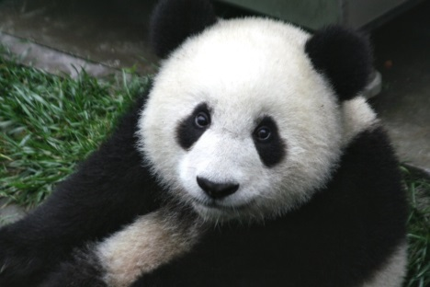
4. Flagship species
charismatic species that tug on the emotional strings of humans
eg. ________________

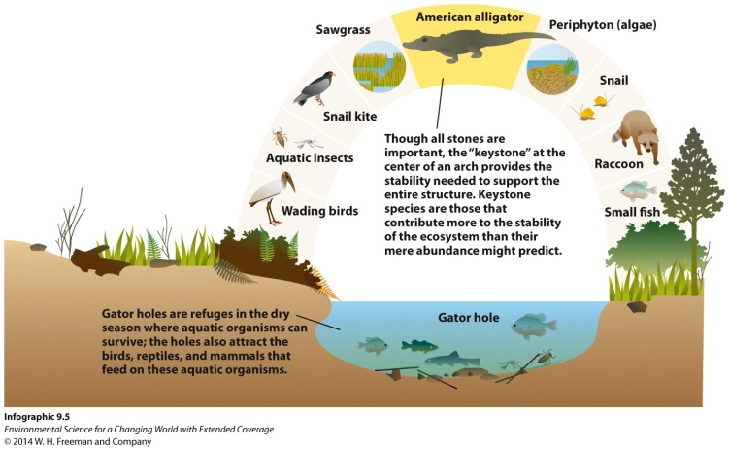

5. Keystone Species
have a major effect on ecological functions
eg.____________________________

Approaches to Conservation—Habitat Based
Habitat Based Conservation uses protected lands for wildlife refuge
Protected Areas
The IUCN (International Union for the Conservation of Nature) specifies six categories of protected areas:
I. Strict nature reserve/wilderness area: protected area managed mainly for science or wilderness protection
II. National park: protected area managed mainly for ecosystem protection and recreation
III. Natural monument: protected area managed mainly for conservation of specific natural features
IV. Habitat/Species Management Area: protected area managed mainly for conservation through management intervention
V. Protected Landscape/Seascape: protected area managed mainly for landscape/seascape protection and recreation.
VI. Managed Resource Protected Area: protected area managed mainly for the sustainable use of natural ecosystems.
Protected areas are interesting places because in a sense they become “islands”.
Isolated areas that contain __________________________ than surrounding, developed areas.
Although they are preserved some biodiversity is lost due to fragmentation and isolation.

Wild Sky Wilderness Area
The Wild Sky Wilderness (2008) is significant because it is the first new federally-designated wilderness in Washington since 1984. Also, unlike many other wilderness areas in the Cascades, Wild Sky protects significant amounts of high productivity low-elevation forest.
Located in the Mt Baker-Snoqualmie National Forest
Many aspects much be looked at before designating an area as protected.

Let’s compare single large areas to several small areas

Single large area | Several Small areas

On your notes circle the option in A that you think is the best to conserve endangered animals. Then do the same for B, C, D, E, and F. For each answer, write why you circle that one.

