**[](http://images.google.com/imgres?imgurl=http://paul.kedrosky.com/WindowsLiveWriter/LerachtheLoraxIMeantNoHarm_A261/lorax_2.jpg&imgrefurl=http://paul.kedrosky.com/archives/2008/06/02/lerach_the_lora.html&h=300&w=276&sz=33&hl=en&start=33&um=1&tbnid=cLNuQPb63Yc0jM:&tbnh=116&tbnw=107&prev=/images%3Fq%3Dthe%2Blorax%26start%3D20%26ndsp%3D20%26um%3D1%26hl%3Den%26safe%3Dactive%26rlz%3D1T4GGLJ_en___US211%26sa%3DN)Populations**

**Characteristics and Issues**

**Population Characteristics**

* The definition of population is a group of individuals of the same species inhabiting the same area at the same time.

**Using the information from the power point label the logistic curve below with the following terms:**

**Lag phase**

**Exponential phase**

**Deceleration Phase**

**Stable Equilibrium phase**

**Carrying capacity**

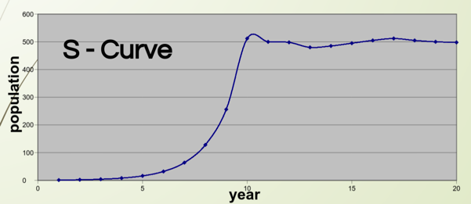

**Define each of the terms above in the space below.**

**Lag phase**

**Exponential phase**

**Deceleration Phase**

**Stable Equilibrium phase**

**Carrying capacity**

**There are 4 main categories of limiting factors. List them below.**

**Population Density and Spatial Distribution**

* **Population density** is the _________________________________________________________.
* Dispersal: Movement of individuals from __________________________________________  
  _____________________________.
* Emigration: Movement __________ an area.
* Immigration: Movement __________an area.

**Reproductive Strategies and Population Fluctuations**

* Species can be divided into two broad categories based on their _____________________________:
* **K-strategists**
* **r-strategists**
* K-strategists:
* __________________________________________________________________________  
  ___________________________________________________________________________.
* r-strategists:
* Typically, these are ___________________________________________________________  
  ____________________________________________________________________________.
* K-strategist characteristics include:
* Usually occupy relatively __________________________________.
* _____________________________
* ___________________________
* Produce few offspring
* Provide substantial parental care
* Reproductive strategy is to invest a great deal of ________________ in producing a _____________________that have a good chance of living to reproduce.

K-strategists are controlled by density-dependent limiting factors.

Examples: __________________________________________

* r-strategist characteristics include:
* _________________________________
* Produce ____________________________
* Little if any parental care
* Exploit ________________________________.
* Regulated by ________________________________________, of which weather is the most important factor
* Fertility, size of breeding territory, predation or disease are examples of density-dependent limiting factors for r-strategists.
* Usually __________________________________________________ (boom-bust cycles).
* Reproductive strategy is to produce large numbers of offspring to overcome high mortality.
* 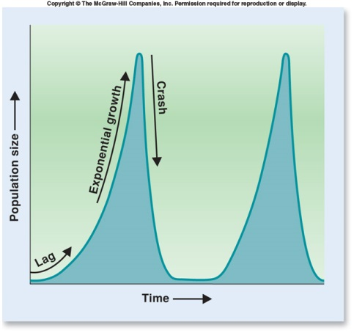Examples: _______________________________________________
* r-strategists are controlled by density-independent limiting factors.
* This graph depicts an r-strategist population. There is a _________________ followed by ____________  
  __________________. Instead of entering equilibrium, there is a ___________ followed by another _____________________ and so on.
* K and r strategists can also be explained in survivorship curves.
* A **survivorship curve** shows the ______________  
  _________________________.
* Three types of survivorship curves can be recognized:
* Species with _______________________________________.
* Species with _____________________________________________________.
* Species with _____________________________________________________.

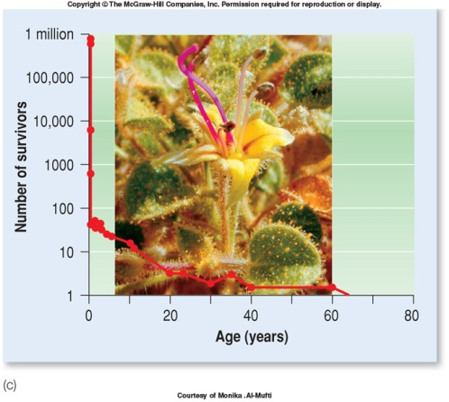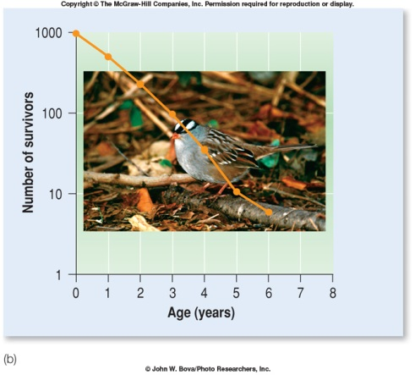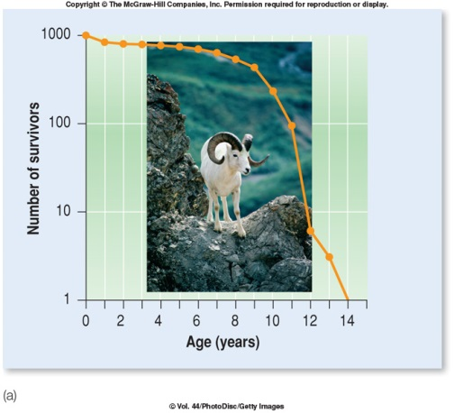

**Population Data Collection**

There are __________________ to collect data on population.

* Which method is used depends on ______________________________________________________.
* Mark-release-capture method
* Used with ______________________
* The particular organism of interest is ______________________ (as many as can be caught in a particular area. and marked with an obvious identifier (eg. paint).
* The organisms are ___________________________.
* The organisms are recaptured and a count of how many have the paint mark are tallied.
* A calculation is made and a population estimate is formulated.

The calculation used is called the Lincoln Index.

P = N1 x N2

R

Where P = ______________________________

N1 =___________________________

N2 = __________________________________

R = ____________________________________________________________________

* The second type of data collection is the ______________________________.
* Used for ___________________________________, such as plants.
* Observer delineates a predetermined area.
* Observer counts all organisms occurring within that area.
* Usually several areas within a habitat will be marked off.