**[](http://images.google.com/imgres?imgurl=http://paul.kedrosky.com/WindowsLiveWriter/LerachtheLoraxIMeantNoHarm_A261/lorax_2.jpg&imgrefurl=http://paul.kedrosky.com/archives/2008/06/02/lerach_the_lora.html&h=300&w=276&sz=33&hl=en&start=33&um=1&tbnid=cLNuQPb63Yc0jM:&tbnh=116&tbnw=107&prev=/images?q%3Dthe%2Blorax%26start%3D20%26ndsp%3D20%26um%3D1%26hl%3Den%26safe%3Dactive%26rlz%3D1T4GGLJ_en___US211%26sa%3DN)Environmental Economics and Consumption**

At the end of this unit you will know:

* How the ecological footprint relates to the use of natural capital and interest
* How we can use factors influencing our actions to reduce environmental impact
* Differences between costs and benefits of conventional economics and environmentally based economics
* Start to recognize what sustainable development is.

Closed-Loop System

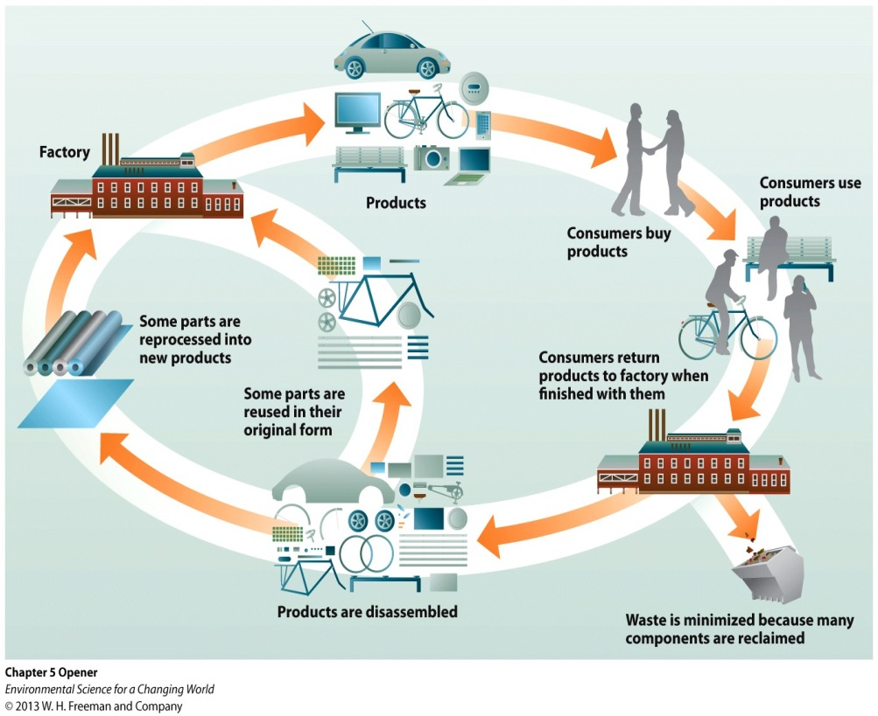

Compare and contrast the two pictures to the right.

Which system decreases a society’s ecological footprint?

In which system do you think the economy would suffer the most? Why do you think this?

In which system do you think there will be more jobs? Why do you think this?

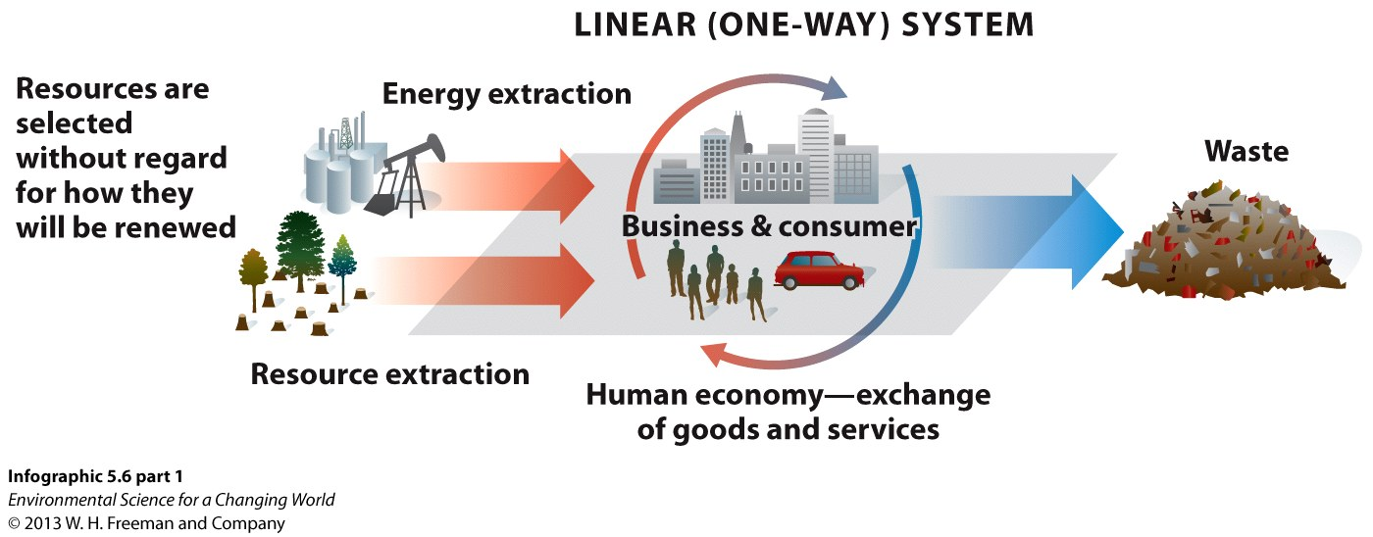

Which system is more sustainable?

Which system does the Wall E video represent?

Main Concept #1

Main Concept #2

What is natural capitalism? How did the carpet company follow this model of economics?

What is classical capitalism? Can you think of a company that follows this model of economics?

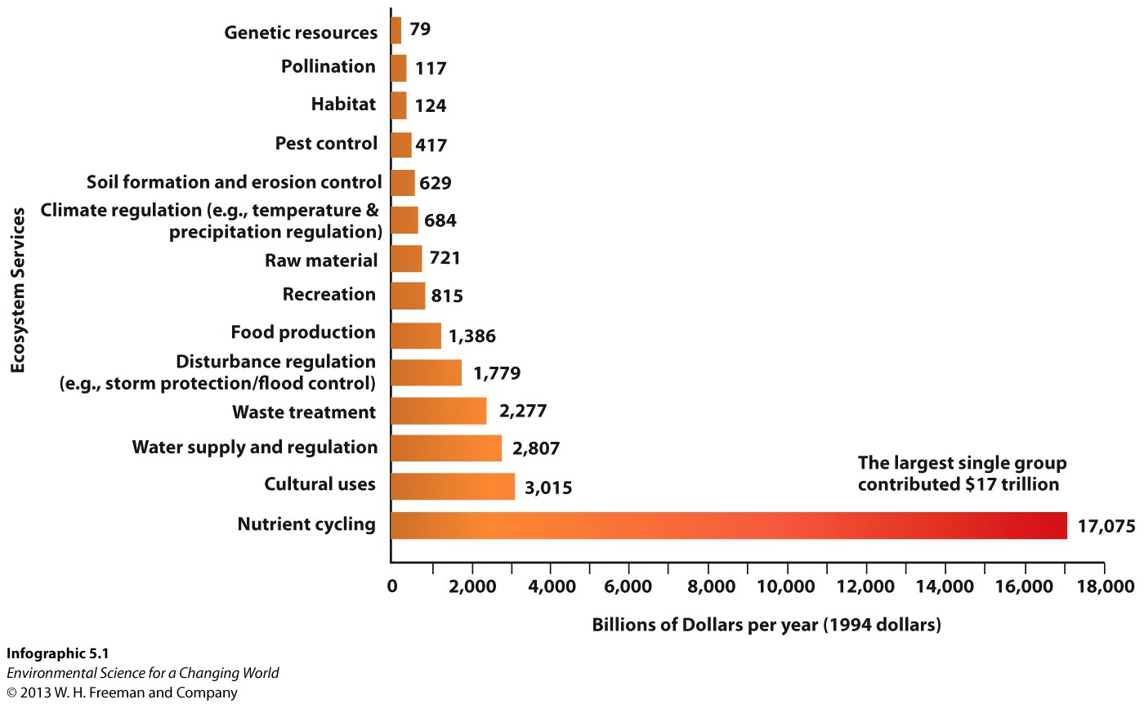

On the graph to the left put a star next to an ecosystem service and a circle next to an ecosystem good.

*Value of ecosystem goods and services*

Study the graph to the left and think about this… what percentage of our economy is based on ecosystem goods and services?

*Value of ecosystem goods and services*

If it weren’t for ecosystem services and goods, would we have an economy at all? Why do you think this?

According to this graph does it make good fiscal sense to live unsustainably? In other words, does it make sense for our economy now and in the future to continue to disregard the environment?

An Ecological Footprint is _____________________________________________________________________________

__________________________________________________________________________________________________

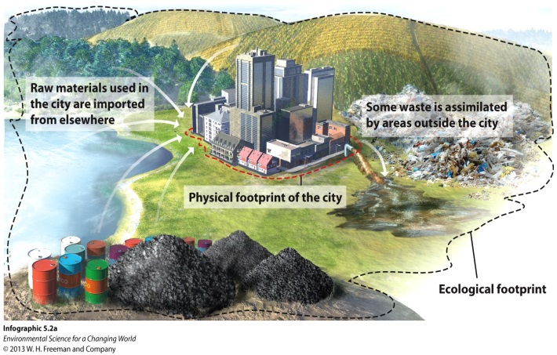Why is the ecological footprint of a city so much larger than its physical footprint?

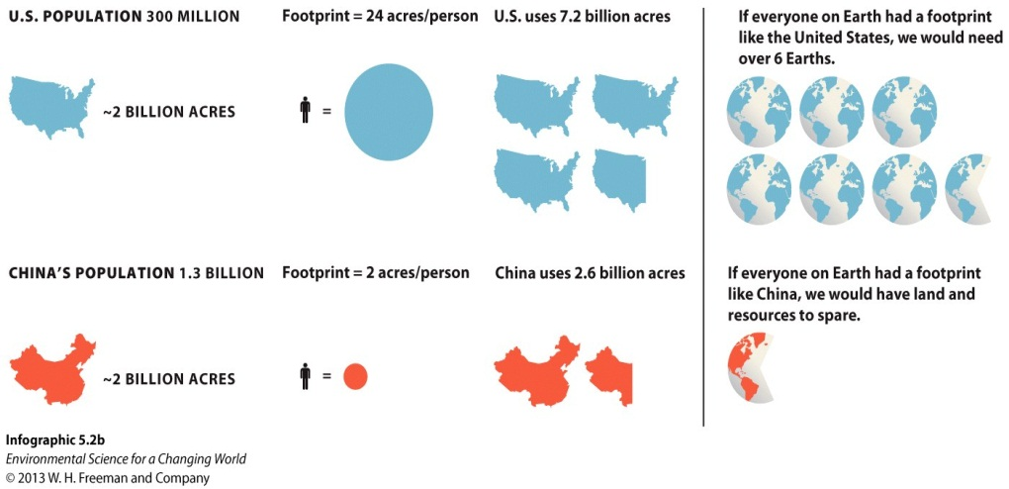

How can we criticize China for having such a large population when Americans have such a bigger impact on the planet?

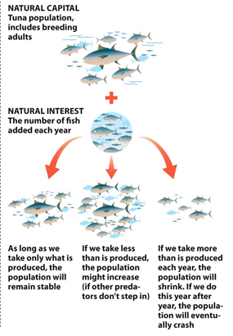

Natural Capital is ___________________________________________________________

Natural Income (interest) is ___________________________________________________________

In the picture to the right circle the 2 options that keep the system sustainable.

What is “restorative enterprise” and how did the carpet company achieve this?

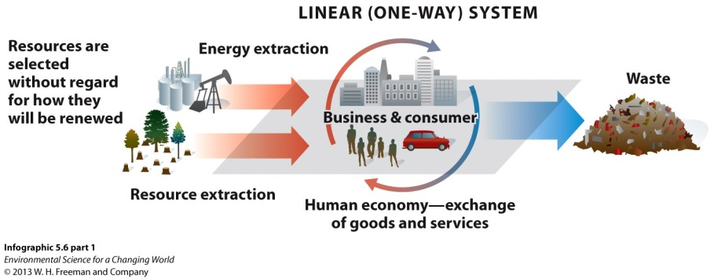

Linear production models assume

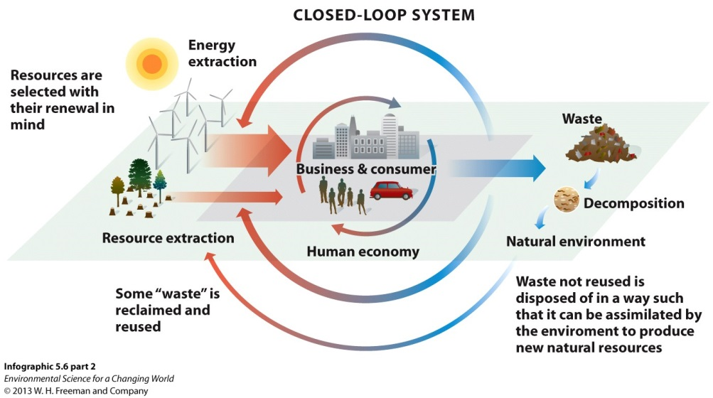

Closed-loop systems consider

Challenges to moving to sustainability: