**[](http://images.google.com/imgres?imgurl=http://paul.kedrosky.com/WindowsLiveWriter/LerachtheLoraxIMeantNoHarm_A261/lorax_2.jpg&imgrefurl=http://paul.kedrosky.com/archives/2008/06/02/lerach_the_lora.html&h=300&w=276&sz=33&hl=en&start=33&um=1&tbnid=cLNuQPb63Yc0jM:&tbnh=116&tbnw=107&prev=/images?q%3Dthe%2Blorax%26start%3D20%26ndsp%3D20%26um%3D1%26hl%3Den%26safe%3Dactive%26rlz%3D1T4GGLJ_en___US211%26sa%3DN)Human Population**

**Human Population Growth**

The human population growth curve has ________________________________followed by a

_____________________________________________________ that is still rapidly increasing.

* This kind of curve is called a ___________________________________.
* 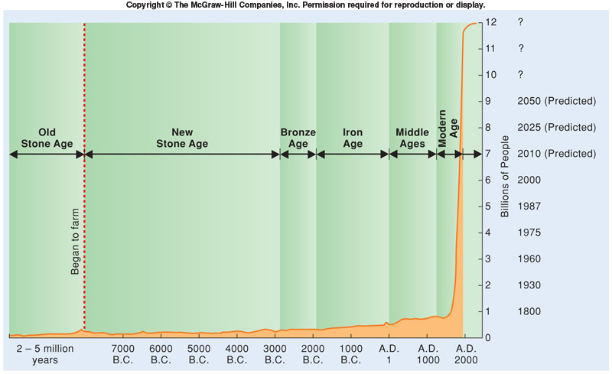

The one major reason for the increasing human population growth rate ______________________:

* ______________________ affects:
* _______________________
* causes a consequential decrease in death rates (increase in life expectancy).
* ________________________
* Humans are able to substitute and adapt easily to changes in resources
* _________________________
* Hygiene
* Waste treatment
* Because of technology, it is difficult to _________________________________________ of the human race.
* Human carrying capacity must take into consideration:
* Rate of ______________________________________________
* Level of _____________________ and extent of _______________________ in global life-support systems.
* Recycling, reusing, and reducing can __________________ human carrying capacity.
* Regardless, as the population grows ________________________________________  
  __________________________________________________________________

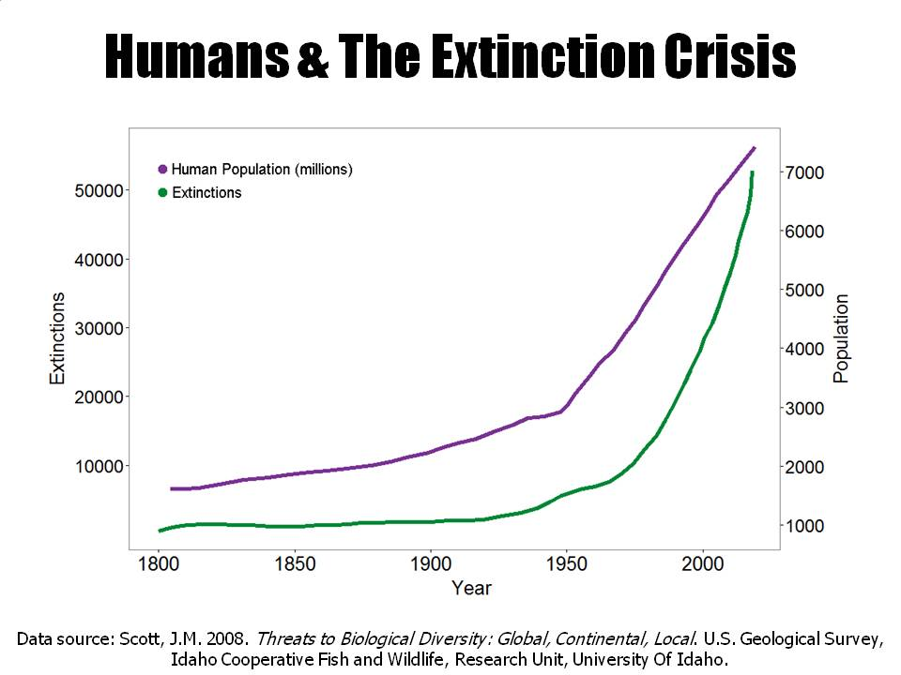Study the graph. What is the relationship between human population and extinction?

How does this relate to the 1st Law of Thermodynamics and the Law of Conservation of Matter?



On top of that _________________________________________________________________

* The _____________________________ for the human population is calculated by the following equation:

**70 / annual rate of increase (%)**

Eg. ( 70 / 2.0% = 35 years )



On the graph below label the x-axis “Years to Double the Human Population” and on the y-axis label “Rate of Annual Increase”. Predict what you think the doubling time graph looks like by using a pencil. Then use a pen to draw the actual doubling time graph I show you.

|  |  |  |  |  |  |  |  |  |  |  |  |  |  |  |
| --- | --- | --- | --- | --- | --- | --- | --- | --- | --- | --- | --- | --- | --- | --- |
|  |  |  |  |  |  |  |  |  |  |  |  |  |  |  |
|  |  |  |  |  |  |  |  |  |  |  |  |  |  |  |
|  |  |  |  |  |  |  |  |  |  |  |  |  |  |  |
|  |  |  |  |  |  |  |  |  |  |  |  |  |  |  |
|  |  |  |  |  |  |  |  |  |  |  |  |  |  |  |
|  |  |  |  |  |  |  |  |  |  |  |  |  |  |  |
|  |  |  |  |  |  |  |  |  |  |  |  |  |  |  |
|  |  |  |  |  |  |  |  |  |  |  |  |  |  |  |
|  |  |  |  |  |  |  |  |  |  |  |  |  |  |  |
|  |  |  |  |  |  |  |  |  |  |  |  |  |  |  |
|  |  |  |  |  |  |  |  |  |  |  |  |  |  |  |
|  |  |  |  |  |  |  |  |  |  |  |  |  |  |  |
|  |  |  |  |  |  |  |  |  |  |  |  |  |  |  |
|  |  |  |  |  |  |  |  |  |  |  |  |  |  |  |
|  |  |  |  |  |  |  |  |  |  |  |  |  |  |  |
|  |  |  |  |  |  |  |  |  |  |  |  |  |  |  |

**Population growth rate** is the _____________________________________________.

**Birth rate and Death Rate**

* **Crude birth rate** is the childbirths per ___________________________________.
* It can be represented by CBR = (n/p) x 1000 where n = ________________________ in that year, and p = _____________________________________.
* **Crude death rate** is the deaths per ___________________________________.
* It can be represented by CDR = (n/p) x 1000 where n = __________________________ in that year, and p = _______________________________.
* The **rate of natural population growth** (natural in that it does not take into account migration is:
  + For example,

Madagascar's crude birth rate = 37.89. Its crude death rate = 7.97 . What is its NIR?

Answer: ______________

Using the Madagascar example, what is the population doubling time?

Answer: ________________