Names _________________________________________________________________ Date __________
Ecological Succession and Productivity
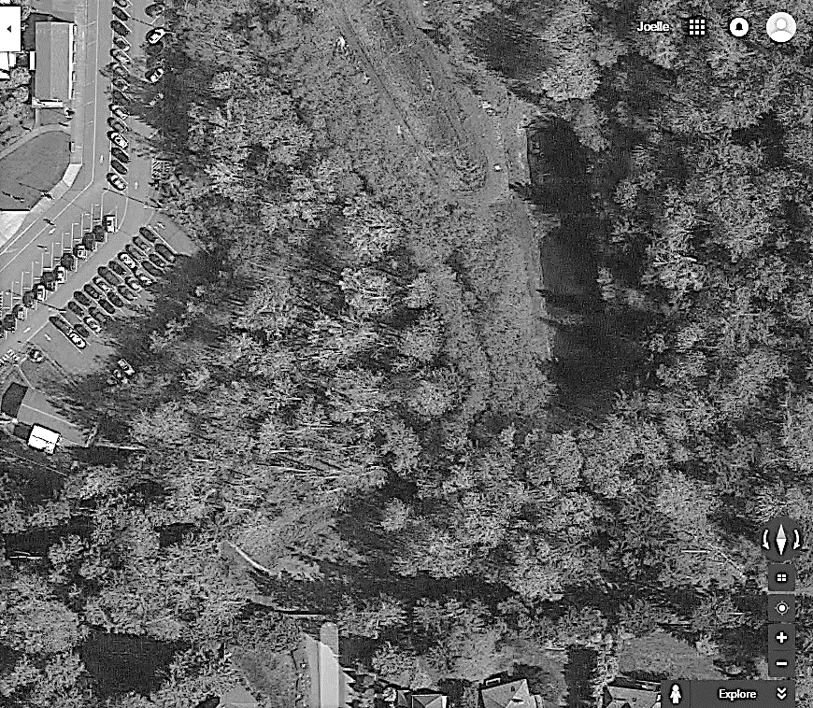
Before going out to the field, mark the different stages of ecological succession on the map below following your teacher’s instructions. Then fill in the answers as the teacher discusses the different characteristics about each part of the forest.

Terrestrial Succession
- Define Primary Succession

- A. Mark on the map with a P above where primary succession is taking place

B. Define Pioneer Species and give an example.

- Define Secondary Succession

- Mark on the map above with an S where secondary succession is taking place.

- Identify the difference between terrestrial succession and aquatic succession.

Workers come down to the pond and maintain the area by cutting down the grass and clearing out the pond. In this way humans are diverting the progression of succession to an alternative stable state by modifying the ecosystem. This diversion may be more or less permanent depending upon the resilience of the ecosystem.

- Seral Stage 1
- In seral stage 1 list the 3 most predominant species.

- Are there any trees? If so what kind are they and about how old are they?
Circle your answer:
0-5 years 6-10 years 11-20 years 20-50 years 50+ years

- What percentage of sun reaches the floor?

- How productive is this stage?

- How biodiverse is this stage compared to the other stages?

- What are the layers of the soil like?

- Is there high nutrient cycling or not in the system?

- Seral Stage 4
- In seral stage 2 list the 3 most predominant species found on the forest floor.

- What kinds of trees are present?

Circle your answer:
0-5 years 6-10 years 11-20 years 20-50 years 50+ years

- What percentage of sun reaches the floor?
- Is the plant life productive?

- Is the plant life diverse?

- What are the layers of the soil like?

- Is there high nutrient cycling or not in the system?

- Seral Stage 5
- In seral stage 3 list the 3 most predominant species found on the forest floor.

- Are there any trees? If so what kind are they and how old are they?
Circle your answer:
0-5 years 6-10 years 11-20 years 20-50 years 50+ years

- What percentage of sun reaches the floor?

- How productive is this stage?

- How biodiverse is the plant life in this stage?

- What are the soil layers like?

- Is there much nutrient cycling in this system?

- Seral Stage 6 (AKA the Climax Community) 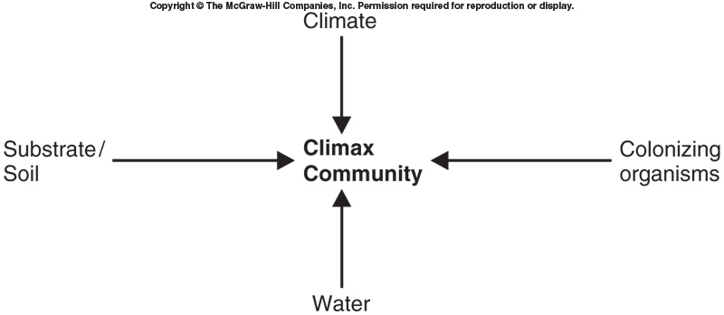
- In seral stage 6 list the 3 most predominant forest floor species.

- Are there any trees? If so what kind are they and how old are they?
Circle your answer:
0-5 years 6-10 years 11-20 years 20-50 years 50+ years

- What percentage of sun reaches the floor?

- How productive is this stage?

- How biodiverse is the plant life in this stage?

- What are the soil layers like?

- What is the nutrient cycling like in this system?

- List 2 negative feedback loops that contribute to the stability of a climax community

10. Of the seral stages we just studied, which do you think is most stable? Why do you think this?
11. Of the seral stages we just studied which do you think is most resilient? Why do you think this?

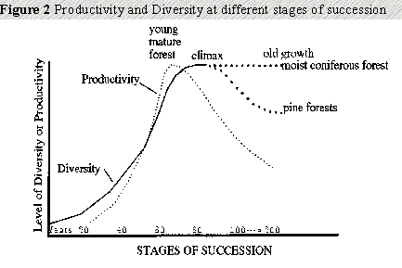
In early stages of succession, gross productivity is low due to the unfavorable initial conditions and low density of producers. The proportion of energy lost through community respiration is relatively low too, so net productivity is high—that is, the system is growing and biomass is accumulating.

In later stages of succession, with an increased consumer community, gross productivity may be high in a climax community. However, this is balanced by respiration, so net productivity approaches 0 and the productivity–respiration (P:R) ratio approaches 1.

12. What is the graph above saying about the diversity of organisms as you move through the seral stages to a stable, climax community?
13. What is the graph above saying about the productiviy of the system as you move through the seral stages to a stable, climax community?

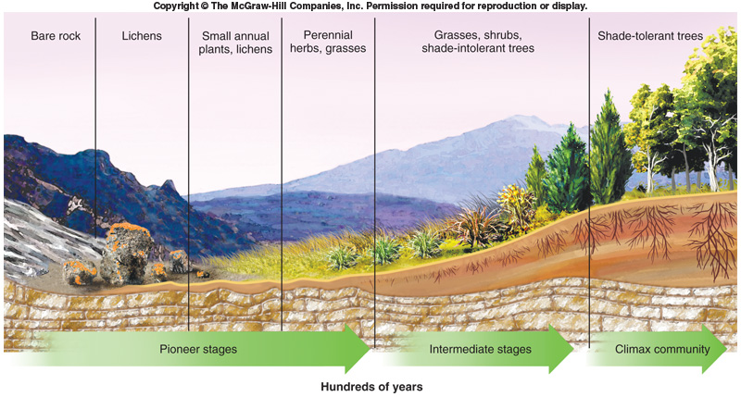
Primary Terrestrial Ecological Succession
14. What kind of succession is happening in the picture above?
Aquatic Succession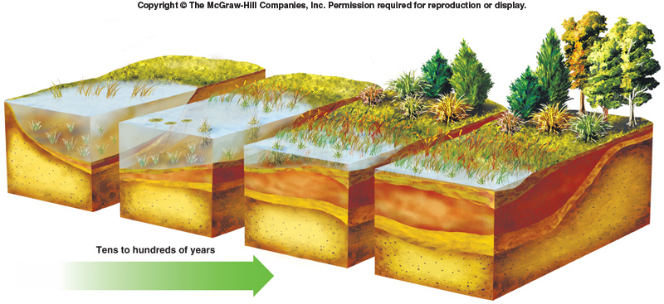
15. Circle on the picture above what stage our Skyline ponds are in.
16. a. According to the picture above, is it possible for ponds and lakes to turn into meadows and then forests?
b. Circle the picture that shows this stage.

