Sustainability Unit

Collage—students make a collage of the things they think are important for a utopian society

Using the collage each student fills in the following chart:

|  |  |  |
| --- | --- | --- |
| Social | Economical | Environmental |
|  |  |  |
|  |  |  |
|  |  |  |
|  |  |  |
|  |  |  |

Then we will make a class chart—I would like to see student up and moving around, but I don’t know how to do this. Maybe have students make a chart for a group of four on a big piece of paper and then we will post the papers in front of the class to see similarities (and differences).

Students draw a picture of a utopian society including all the things they think are important

Read the case study of the town in Brazil.

Have students read the different definitions of sustainable and choose the definition they like the most.

Using the IB definition of sustainable (development that meets present needs without compromising the ability of future generations to meet their own needs), ask students to rate the importance of social, economic, environmental in order from most important to least important—have them do this in a group of 4. Students should argue a lot here and hopefully come up with the idea that they are all equally important. What if they don’t come up with that?

Discuss the fact that in a sustainably developed society, all three categories are just as important which leads us to the sustainable development Venn diagram—pass out a piece of paper for them to draw the Venn diagram, the definition of IBs sustainable development, picture of a lake scene (to get the idea across that nonrenewable resources are not ever sustainably harvested.

Move into economics and natural capital by reading the 3 little pigs.

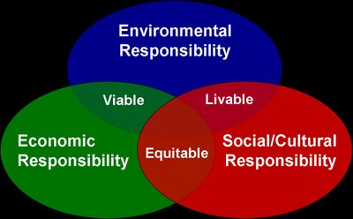

**Sustainability Notes**

Summarize Curitiba: A Model Sustainable City Case Study:

IB Definition of Sustainability:

Sustainable Development Venn Diagram

Characteristics that define sustainability:

* Renewabilty
* Substitution
* Interdependence
* Adaptability
* Institutional commitment

Make a list of the resources (capital) that are renewable and nonrenewable

Renewable—class definition

Nonrenewable—class definition

Circle the list that can be sustainably harvested.

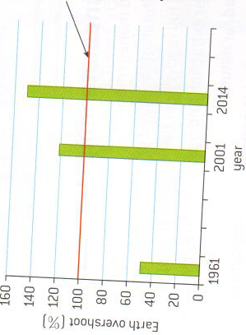According to the United Nations, humanity has overshot its sustainable level of natural capital exploitation.

You can find how much can be sustainably harvested by looking at the productivity of your resource (capital).

Would GPP or NPP be more appropriate to help you calculate sustainability?

Let’s look at the problem below.

What is the maximum sustainable yield of timber from this forest?

* A. 1.8 kg m-2 yr-1
* B. 2.2 kg m-2 yr-1
* C. 43.8 kg m-2 yr-1
* D. 44.2 kg m-2 yr-1