Name _____________________________________________ Date _____________

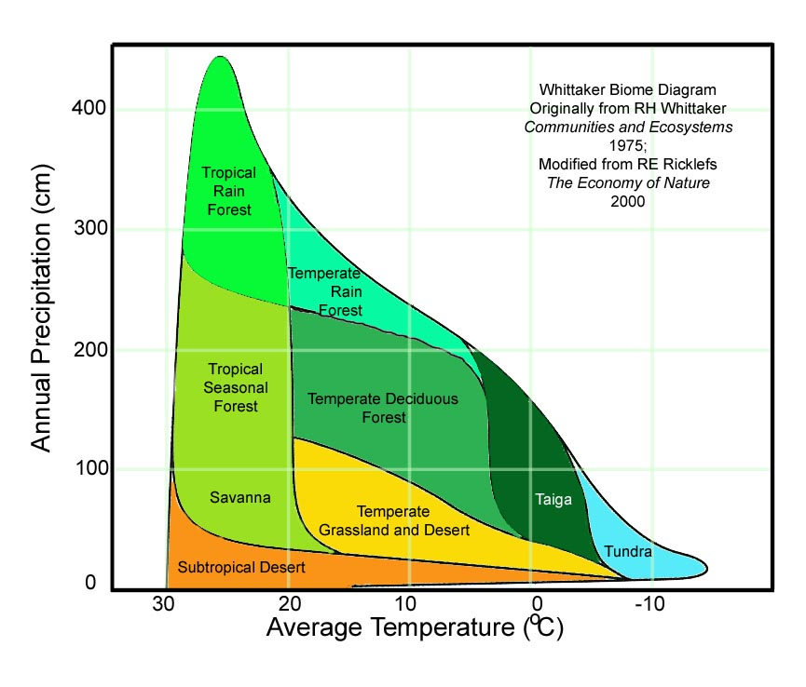
Biomes
This worksheet acts as both notes and a worksheet. You will need to study this when preparing for the test

Objectives:
1. To define biome
2. To understand how climate drives the different types of biomes
3. To realize that location on the globe dictates the type of biome.
4. To understand that different biomes support different types of life.
5. To compare 4 different biomes.

Biomes are collections of ecosystems sharing similar climatic conditions that can be grouped into five major classes: aquatic, forest, grassland, desert and tundra. Each of these classes has characteristic limiting factors, productivity and biodiversity.

According to the picture on the right what climatic conditions does one find in the tundra?

According to the picture what climatic conditions are in the temperate rain forest?

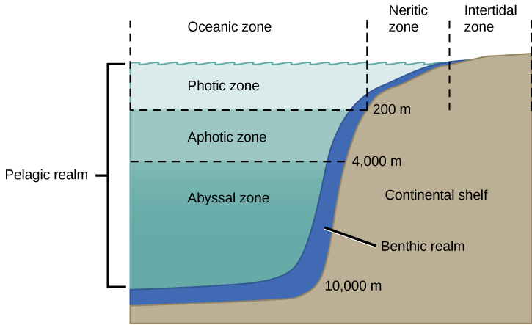
There are also aquatic biomes. According to the picture on the left, what are the 4 major aquatic biomes?

Tricellular Model of Air Circulation—in the space below label where the cold air is and the warm air.

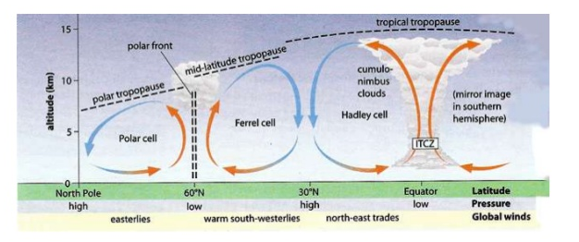

Differences in climate explain why one area of the earth's land surface is a desert, another a grassland, and another a forest. Global air circulation patterns account for different types of deserts, grasslands, and forests as well.
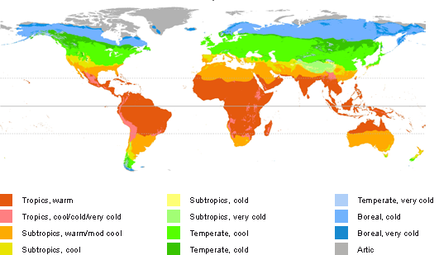
A global ecological zone map like the one shown to the right shows how scientists have divided the world into several major biomes —large terrestrial regions--each characterized by certain types of climate and dominant plants.
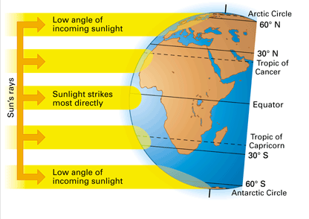
Global Insolation

Each biome has its characteristic level of productivity and insolation. These 2 terms are related in the fact that insolation (the amount of solar radiation reaching the area) dictates how productive the biome is. In other words, the more sun that reaches the surface, the more photosynthesis, so, the more food that is available in the ecosystem, and thus, higher productivity.
According to the picture above where does the planet receive the most insolation?
What type of biome exists in this area?
Where does the planet get the least amount of insolation?
What type of biome exists in this area?
Ms. Nelson will show you pictures of some major biomes. Fill in the chart below according to the power point.
Biome | Insolation | Productivity | Temp | Precipitation | Plants/animals | Human Impact
Desert

Tropical Rainforest

Deciduous Forest

Grassland

Tundra

Taiga

The variety of terrestrial biomes and aquatic systems is important for Earth’s biodiversity and a vital part of the earth's natural capital (services and resources provided by the natural environment). By looking at the global ecological zone map, you can see how the world's major biomes vary with climate.
On global ecological zone maps, biomes are shown with sharp boundaries, and each biome is covered with one general type of vegetation. In reality, biomes are not uniform. They consist of a mosaic of patches, each with somewhat different biological communities but with similarities typical of the biome. These patches occur mostly because of the irregular distribution of the resources needed by plants and animals and because human activities have removed or altered the natural vegetation in many areas.
The figure below shows how climate and vegetation vary with both latitude and elevation . If you climb a tall mountain, from its base to its summit, you can observe changes in plant life similar to those you would encounter in traveling from the equator to the earth's northern polar region. For example, if you hike up a tall Andes mountain in Ecuador, your trek will begin in a tropical rain forest and end up on a glacier at the summit.
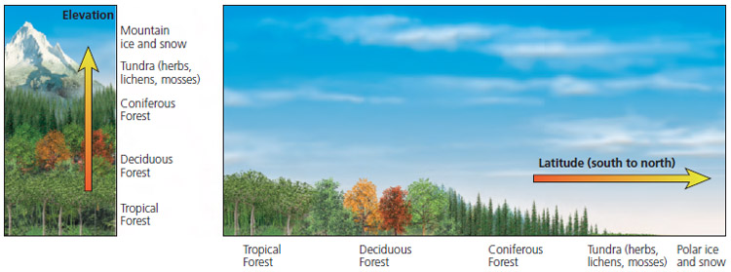
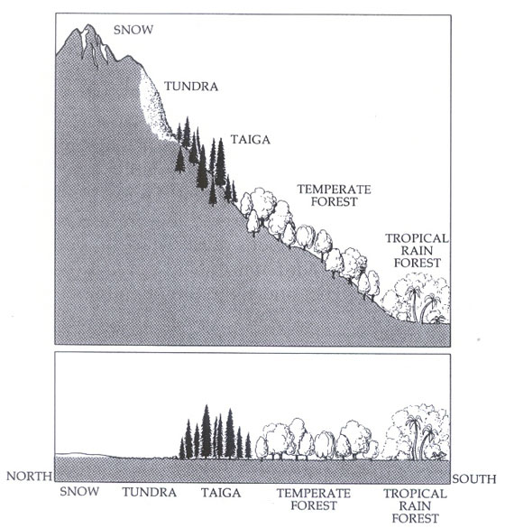
Differences in climate, mostly in average annual precipitation and temperature, lead to the formation of tropical (hot), temperate (moderate), and polar (cold) deserts, grasslands, and forests. These different changes in communities as you move to different latitudes altitudes are called zonations.
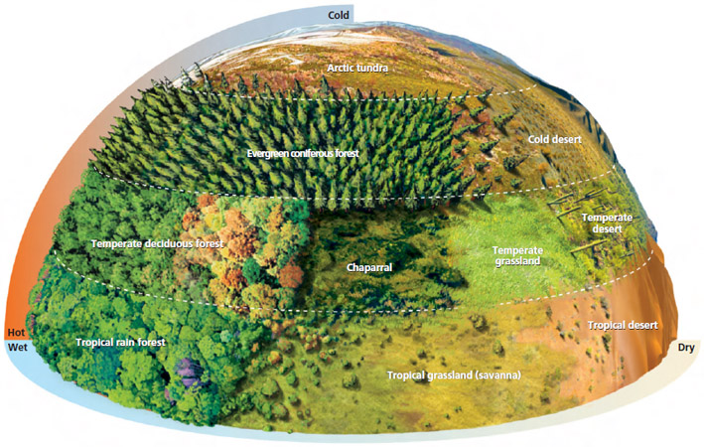

You will now make a biome booklet that will compare 4 different sets of biomes. You will need to compare the two different biomes by including the following information on each panel of the booklet:
- insolation,
- precipitation (for terrestrial),
- productivity,
- temperature
- a food web
You may choose from the following sets of biomes. Remember, you must choose at least 4 sets.
- Cloud forest and alpine forest
- Tropical coral reefs and hydrothermal vents
- Temperate bogs and tropical mangrove forests
- Ocean and estuary
- Tropical rainforest and temperate broadleaf forest
- Grass savanna and temperate steppe
- Chaparral and coniferous forest
- Tundra and polar ice

