Name ___________________________________________________ Date __________________

Case Study on Extinct, Endangered and Once Endangered Species and Natural Areas
The International Union of Conservation of Nature (IUCN) publishes data in the “Red List of Threatened Species” in several categories. There are several factors that scientists take into considered when trying to decide if a species should be listed and under which category it should be listed. Factors used to determine the conservation status of a species include:
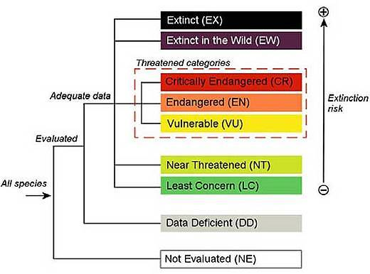
- population size,
degree of specialization,
- distribution,
- reproductive potential and behavior,
- geographic range and degree of fragmentation,
- quality of habitat,
- trophic level,
- and the probability of extinction.
Your task:
Search “Red List” online. At the top of the home page you will find different categories such as “vulnerable”, “critically endangered”, “extinct in the wild”, etc.
- Choose one species from each of the following 3 categories (critically endangered species, extinct species, least concern) and complete the table below on each species.
***You must get your endangered and extinct species approved by Ms. Nelson who is not interested in learning about pandas, elephants, and tigers AGAIN. In other words, the species you choose should be less well known. You may want to consider a plant, insect, amphibian, or fish.***
- Choose one natural area that is being threatened by human activities and complete the table below. Your information should area include;
- Please include references at the bottom of each chart and cut and paste a picture of each organism/habitat.
Picture of species
Extinct Species
Name of Species __________________________________________________
Common name

Scientific name
Geographic range
Habitat and ecology
When did it become extinct?
References:

Critically Endangered Species
Picture of species
Common name

Scientific name
Where does it live?
Habitat and ecology

Why is it critically endangered?
Population

The species ecological role and possible consequences of it becoming extinct
Conservation efforts
References:

Least Concern
Picture of species
Common Name
Scientific Name
Geographic range
Habitat and Ecology
Population
Threats
Conservation Actions
References:
The next section is not found on the Red List site. You will have to search this on your own.
A Natural Area that is Threatened by Human Activities
Picture of Area
Name and Location of Natural Area ___________________________________________
Ecological Pressures that caused it to become threatened
Socio-political pressures that caused it to become threatened
Economic pressures that caused it to become threatened
The consequent threat to biodiversity

References:

