Threats to Biodiversity
- Factors that lead to loss of biodiversity include both _________________________________________________
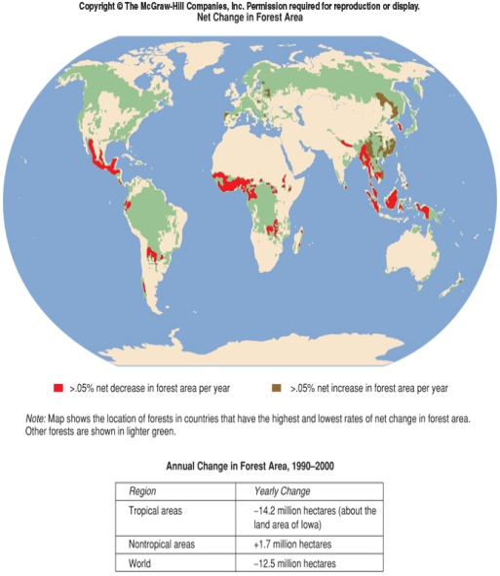
  - Nonhuman activities
    - Natural hazard events
      - Examples
        - _________________
        - Flood
        - __________________________________
        - Ice age (think mammoths)
        - Meteor impact (_______________________________)
  - Human activities
    - ______________________________________
    - Overexploitation
    - Introduction of exotic species
    - _____________________________
    - Agricultural practices
Look at the graphs below. Is there a correlation between species extinction and human population growth?
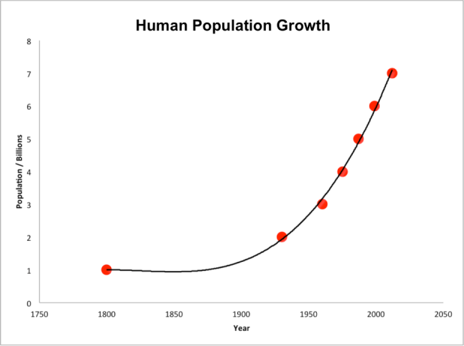
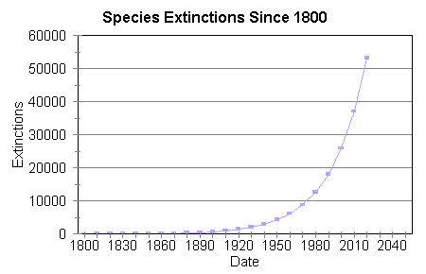

- Reasons for endangerment:
- 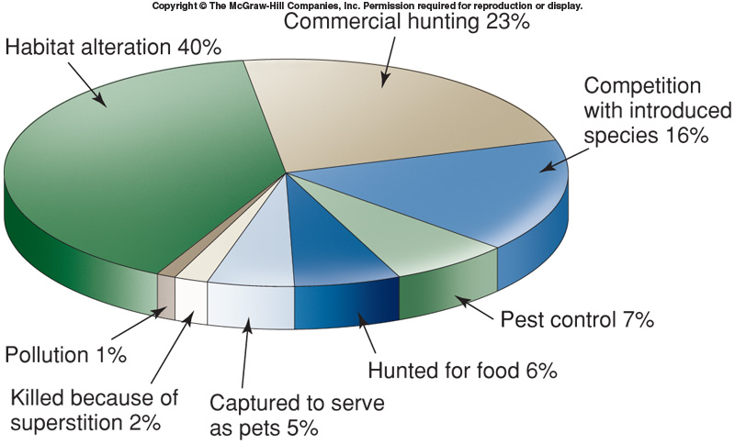

- Habitat Destruction
  - The World Conservation Union estimates that __________________ of threatened species are under threat as a result of _________________________________________________________________.
  - Habitat loss and fragmentation are thought to be a major cause of past extinctions.
  - About 40% of the world’s land surface has been converted to ___________________ and permanent pasture.
    - This leads to _________________________—one type of organism, for example corn only)
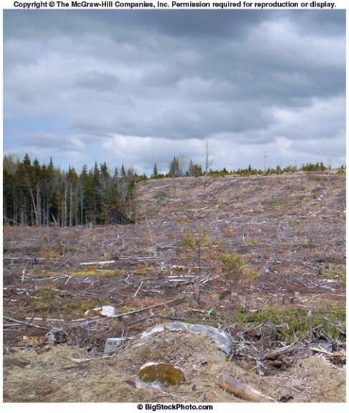
  - Typically, the most productive natural ecosystems (_____________________________________) are the first to be modified by humans.
  - Pressures to modify the environment are greatest in areas with ________________________________.
- Habitat Destruction due to Deforestation
  - Originally, half of the U.S., three-fourths of Canada, and almost all of Europe, and significant portions of the rest of the world were forested.
  - _______________________________is the process of destroying a forest, often for the purposes of fuel, building materials, or to clear land for farming.
  - ______________________________ have greater species diversity than any other ecosystem.
    - They are not as likely as temperate forests to regenerate after logging due to poor soil characteristics.
    - Currently, few tropical forests are being managed for __________________________________.
  - Several concerns are raised by tropical deforestation:
    - It significantly ______________ species diversity in the world.
    - It impacts the climate via lowered ______________________.
    - Deforested lands are easily _______________________.
    - Without the forests to trap CO₂, there may be increased _____________________________.
    - Human population pressure is greatest in tropics, and still increasing.
  - Many lumber companies maintain forest plantations as crops and manage them in the same way farmers manage crops.
    - Plant ____________________, even-aged forests of fast growing hybrid trees.
    - Competing species are controlled by fire, and insects controlled by spraying.
    - Trees mature to harvestable size in as low as ___________________________ (vs. 100).
    - Quality of lumber reduced.
    - Low species diversity and wildlife value.
- Habitat Destruction due to Grazing
  - The conversion of rangelands to grazing by domesticated animals has major impacts on biodiversity.
    - Selective eating habits of livestock tend to reduce certain species of ______________________ and ______________________________.
    - Important to regulate number of livestock on rangelands, especially in dry areas.
      - Overgrazing is a severe problem where human population pressures are great.
      - _____________________________ can occur due to overgrazing.
- Threats to Marine Biodiversity
  - Trawls are nets dragged along the bottom.
    - They disturb the seafloor and cause habitat damage.
  - About 25% of catch is undesirable, and thus _________________, but they are usually dead, and their removal further alters the ecological nature of the seafloor.
- _______________________________
  - According to the World Conservation Union, overexploitation is responsible for over __________________ of endangered animal species and 8% of endangered plant species.
  - The World Wildlife Fund estimates illegal trade in wild animals globally produces _______________________ annually.
    - These activities have already resulted in local extinctions.
  - The United Nations estimates 70% of world’s marine fisheries are overexploited or are fully exploited and in danger of being overexploited.
    - Amount of fish caught has remained relatively constant since 1989.
  - Meat from wild animals is often referred to as ______________________________.
    - Examples include chimpanzees, gorillas, leopards, monkeys
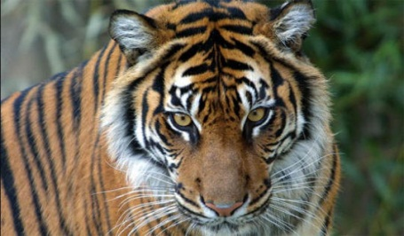
  - The Wildlife Conservation Society estimates 70% of wildlife species in Asia and Africa and about 40% of species in Latin America are being hunted ______________________________much of it for bush meat.
    - Hunting of wildlife is a part of all subsistence cultures.
    - Many kinds of wildlife are considered delicacies and are highly prized for the _______________
_________________________
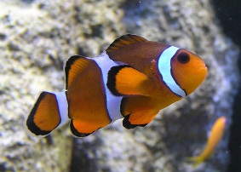
  - Harvest of living animals for the pet and aquarium trade is a significant problem.
    - The method of capture is often problematic.
      - _______________ of bird nests.
      - _____________ used to stun fish.
  - Wildlife are also hunted because parts of the animal may have particular value.
    - __________________________________
    - ___________________________
  - Systematic killing of certain organisms that _______________________________________________ also results in reduced biodiversity.
    - Large predators have been locally exterminated because they preyed on domestic animals.
      - Example: Wolves
  - Pollution
    - Many different types of pollution have lead to a decrease in biodiversity
      - _____________________
      - Soil pollution
- Introduced Species
An introduced species is any organism that was brought to an ecosystem as a result of human actions.
If an environment has ____________________ that the introduced species can exploit, or if the introduced species is a ____________________, original species may be pushed out or die. This particularly happens when there are no predators for the introduced species.
When an introduced species has established itself in a new ecosystem, it is called an ___________________________.
  - Examples include:
