**[](http://images.google.com/imgres?imgurl=http://paul.kedrosky.com/WindowsLiveWriter/LerachtheLoraxIMeantNoHarm_A261/lorax_2.jpg&imgrefurl=http://paul.kedrosky.com/archives/2008/06/02/lerach_the_lora.html&h=300&w=276&sz=33&hl=en&start=33&um=1&tbnid=cLNuQPb63Yc0jM:&tbnh=116&tbnw=107&prev=/images?q%3Dthe%2Blorax%26start%3D20%26ndsp%3D20%26um%3D1%26hl%3Den%26safe%3Dactive%26rlz%3D1T4GGLJ_en___US211%26sa%3DN)Soil**

**Abuses and Conservation**

**Marginal Lands**

* 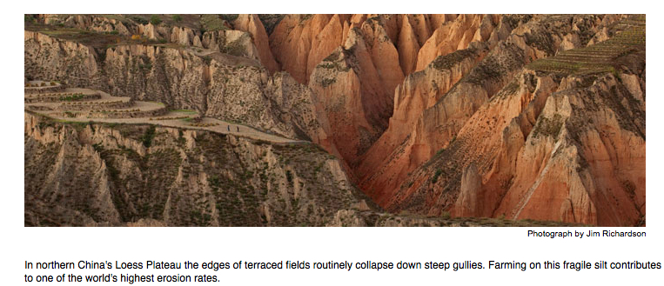Soil ecosystems change through succession. __________________ contains a community of organisms that work to maintain functioning nutrient cycles and that are resistant to ________________________
* Some soils, __________________

________________________, are never good for farming

* + Eg. ______________

These types of soils are called _________  
___________________________

* Fertile soil may be located on slopes. This is also not prime arable land
  + Also called __________________________________

**Abuses of Soil**

* There are 3 main ways that soil is degraded.
* _______________
* ­­­­­­­­­­__________________
* ___________________

**Abuse--Soil Erosion**

* There are 3 different kinds of erosion of soil.
* _________
* _________
* ____________________________
* Worldwide, erosion removes _____________________ of soil per year.
* Made worse by __________________________  
  ________________________________.
* Poor agricultural practices _______________________ and lead to the ___________________  
  ____________________________________.

|  |  |  |  |
| --- | --- | --- | --- |
| **Erosion Type** | **Cause** | **Examples** | **Result(s)** |
|  |  |  |  |
|  |  |  |  |

**Abuse—Soil Toxification**

|  |  |  |  |
| --- | --- | --- | --- |
| **Cause** | **Examples** | **Results** | **Consequences** |
|  |  |  |  |

**Abuse—Salinization**

|  |  |  |
| --- | --- | --- |
| **Cause** | **Results** | **Consequences** |
|  |  |  |

**Soil Conservation Practices**

* Agricultural Potential
* _____________________:
* 11% of land surface is suitable for crops (arable).
* An additional 24% is in permanent pasture.
* ____________________:
* 20% land surface is arable.
* 25% in permanent pasture.
* ________________________:
* 6% land surface suitable for crops.
* 29% can be used for pasture.
* When topsoil is lost, ________________________________________, thus fertilizers must be used to restore fertility.
* This practice ______________________________, and increases sediment load in waterways.
* Fertilizers ___________________________________________________________ which leads to a change in water ecosystems.
* Over _________ of U.S. land is suitable for agriculture, but only ___________ does not require some form of soil conservation practice.

**Soil Quality Management Components:**

* Manage pests and nutrients efficiently.
* Prevents ______________________
* Prevent _______________________.
* Plants don’t grow in compacted soil.
* _______________________________.
* Keeps nutrients from being drawn out of the soil.

Fill in the chart below for ways to prevent soil degradation

|  |  |
| --- | --- |
| * Soil Degradation Type | * Ways to prevent degradation |
| * Erosion |  |
| * Toxification |  |
| * Salinization |  |

**Soil Conservation Practices—Cultivation—Draw an arrow to the picture that represents each type of alternative cultivation**

* **________________________** is tilling at right angles to the slope of the land. Each ridge acts as a small dam.
* 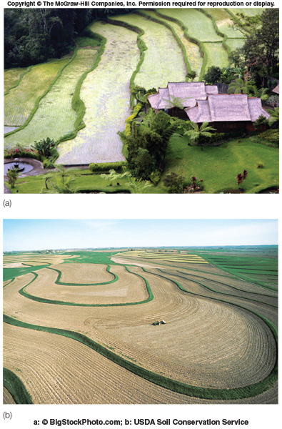Useful on _________________________.
* One of the simplest methods for preventing soil erosion.
* **__________________________** is the practice of alternating strips of closely sown crops to slow water flow, and increase water absorption.
* **__________________________** is the practice of constructing level areas at right angles to the slope to retain water.
* Good for ______________________________.

