**[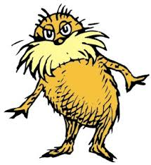](http://images.google.com/imgres?imgurl=http://paul.kedrosky.com/WindowsLiveWriter/LerachtheLoraxIMeantNoHarm_A261/lorax_2.jpg&imgrefurl=http://paul.kedrosky.com/archives/2008/06/02/lerach_the_lora.html&h=300&w=276&sz=33&hl=en&start=33&um=1&tbnid=cLNuQPb63Yc0jM:&tbnh=116&tbnw=107&prev=/images?q%3Dthe%2Blorax%26start%3D20%26ndsp%3D20%26um%3D1%26hl%3Den%26safe%3Dactive%26rlz%3D1T4GGLJ_en___US211%26sa%3DN)Sustainability and Sustainable Development**

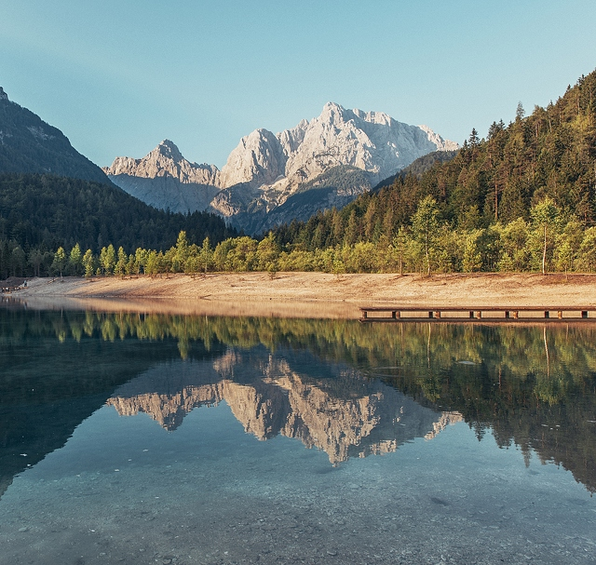The definition of sustainability is __________________________________________________________  
_____________________________________________________________________________________  
_____________________________________________________________

Natural Capital means ______________

________________________________

________________________________

________________________________

List as many examples from this lake scene that you can think of that are natural capital. Write them in the renewable and nonrenewable columns as appropriate.

|  |  |
| --- | --- |
| Renewable Natural Capital | Nonrenewable Natural Capital |
|  |  |
|  |  |
|  |  |
|  |  |
|  |  |
|  |  |
|  |  |

Renewable means

Although renewable can be turned into nonrenewable if…

Nonrenewable means

Natural capital is dynamic because its value can change depending on

How does the bumper of a car represent the idea that natural capital is dynamic?

How does an ecobag represent the idea that natural capital is dynamic?

How does shark fin soup represent the idea that natural capital is dynamic?

Title of Graph:__________________________________________

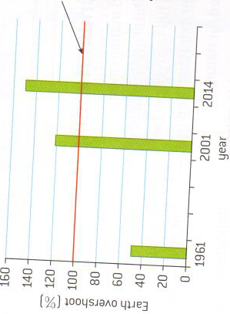**Sustainable Development Graph**



What is the sustainable amount of timber to harvest every year?