UNIT 4: Eukaryotic Cells Name: _____________________

Essential Idea(s):
Eukaryotes have a much more complex cell structure than prokaryotes
IB Assessment Statements and Class Objectives
1.2.U2 | Eukaryotes have a compartmentalized cell structure.  - State the meaning and advantages of eukaryotic cells being “compartmentalized.”
1.2.S2 | Drawings of the ultrastructure of eukaryotic cells based on electron micrographs.  - Recognize features and identify structures in micrographs of eukaryotic cells (inclusive of the plasma membrane, cytoplasm, free 80s ribosomes, nucleus, rough endoplasmic reticulum, Golgi apparatus, lysosome, mitochondria, chloroplast, vacuoles, vesicles, centrioles, microtubules, cilia, flagella and cell wall).  - Given a micrograph, draw and label the ultrastructure of a eukaryotic cell.
1.2.S3 | Interpretations of electron micrographs to identify organelles and deduce the function of specialized cells.  - Explain why cells with different functions will have different structures.  - Identify ultrastructures visible in a micrograph of a eukaryotic cell.  - Given a micrograph of a cell, deduce the function of the cell based on the structures present.
1.4.U3 | Vesicles move materials within cells.  - List two reasons for vesicle movement.  - Describe how organelles of the endomembrane system function together to produce and secrete proteins (rough ER, smooth ER, Golgi and vesicles).  - Outline how phospholipids and membrane bound proteins are synthesized and transported to the cell membrane.
1.2.A1 | Structure and function of organelles within exocrine gland cells of the pancreas.  - State the function of an exocrine gland cell.  - Describe the function of the following structures in an exocrine gland cell: plasma membrane, nucleus, mitochondria, Golgi apparatus, lysosomes, vesicles and endoplasmic reticulum.
1.2.A2 | Structure and function of organelles within palisade mesophyll cells of the leaf.  - State the function of a palisade mesophyll cell.  - Describe the function of the following structures in a palisade mesophyll cell: cell wall, plasma membrane, chloroplasts, vacuole, nucleus, and mitochondria.
1.5.U3 | The origin of eukaryotic cells can be explained by the endosymbiotic theory.  - State the endosymbiosis theory.  - Outline the major events in the origin of eukaryotic cells.  - Describe the evidence for the endosymbiotic theory

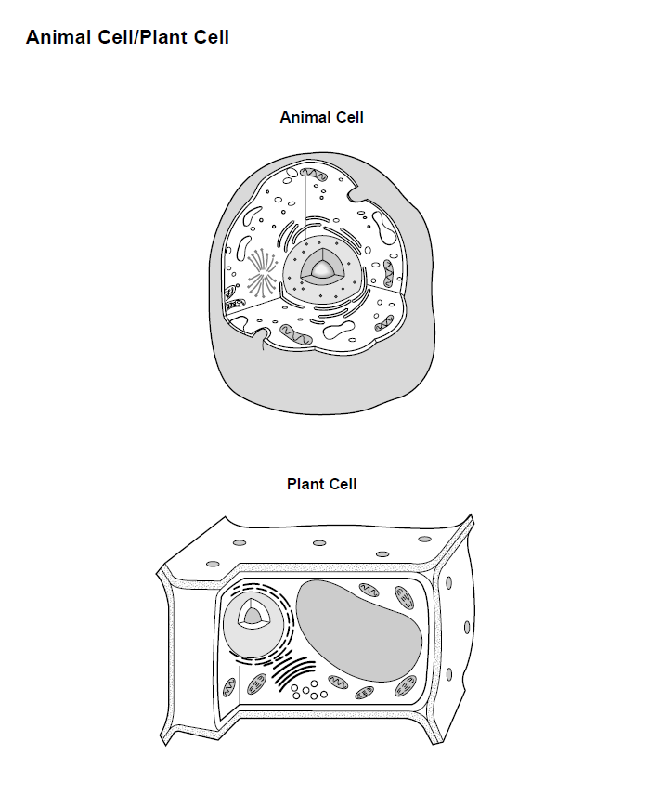
Eukaryotic Cells Structure and Function
Sketch | Details
1 | Name: Plasma (cell) membrane  Function: Gives the cells shape and regulates the movement of substances into and out of the cell.
2 | Name: Mitochondria  Function:
3 | Name: Ribosome  Function:
4 | Name: Rough Endoplasmic Reticulum  Function:
5 | Name: Smooth Endoplasmic Reticulum  Function:
6 | Name: Golgi  Function:
7 |  | Name: Vesicle  Function:
8 |  | Name: Nucleus  Function:
9 |  | Name: Vacuole  Function:
10 |  | Name: Chloroplast  Function:
11 |  | Name: Cytoskeleton  Function:
12 |  | Name: Cilia and flagella  Function:
13 |  | Name: Cell Wall  Function:
14 |  | Name: Extracellular matrix  Function:

ENDOMEMBRANE SYSTEM

Definition of ENDOMEMBRANE SYSYTEM:

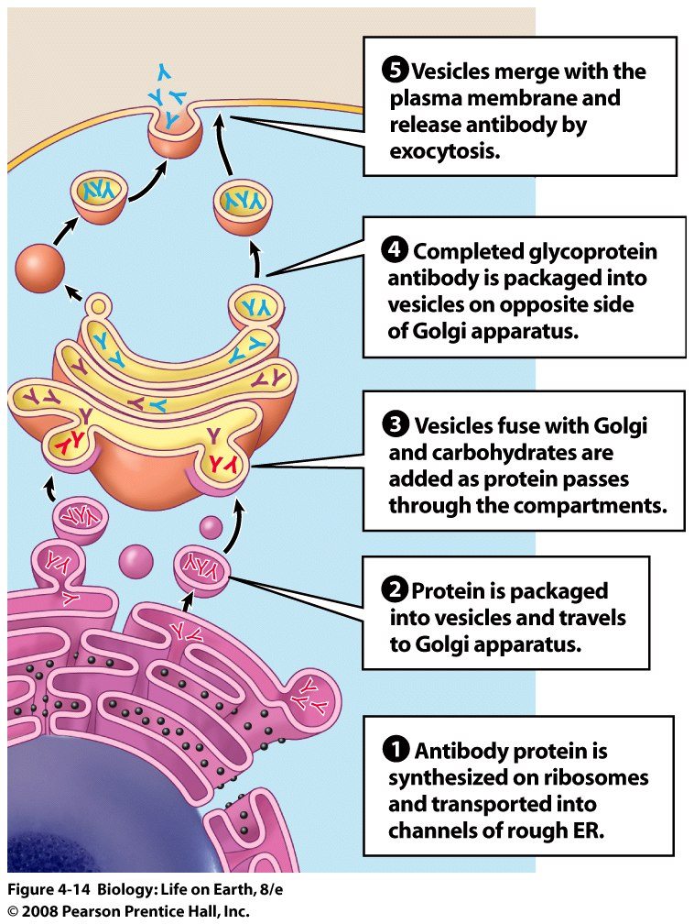

Where did it come from?
- The hypothesis is that eukaryotes evolved from prokaryotes.
- In the early prokaryotic cells, there was an infolding of the plasma membrane into the cytoplasm. We see this in some prokaryotic cells today (the mesosome).
- The infolded membrane began to specialize for particular tasks.
- This would explain why the endomembrane system is a phospholipid bilayer, just like the cell membrane.

Two processes are thought to have led to the ORIGIN OF EUKARYOTES:
These organelles are thought to have arisen via infolding:

1
Infoldings of the prokaryotic cell membrane
Creates internal micro-environments
Advantage = increase efficiency
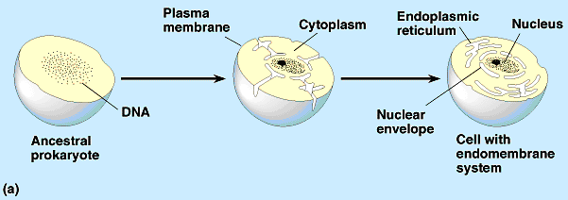

Theory of Endosymbiosis
2
Early eukaryotic cells engulfed aerobic bacteria but did not digest them. Led to the origin of mitochondria.

Early eukaryotic cells engulfed photosynthetic bacteria but did not digest them. Led to origin of chloroplasts.
Structural evidence | Both mitochondria & chloroplasts
Genetic evidence | Both mitochondria & chloroplasts
Functional evidence | Both mitochondria & chloroplasts

