Notes: Habitat Diversity in the Skyline Forest
A habitat is the environment where an animal, plant, or other organism lives. Today we are going to visit 8 different macro habitats in our Skyline forest. Wait. Did you say EIGHT DIFFERENT HABITATS? In such a small area? Wow!!!

A. Stream riparian
B. Road
C. Cedar grove
D. Mixed forest
E. Alder Grove
F. Grassy area
G. Pond
H. coniferous forest
Objectives:
- Explore habitat/species diversity in the Skyline forest
- Understand that greater habitat diversity leads to greater species and genetic diversity
- The ecological resilience of a system, ecological or social, refers to its tendency to avoid such tipping points and maintain stability.
- Diversity and the size of storages within systems can contribute to their resilience and affect their speed of response to change (time lags).
1. Using the map below circle the areas listed above and label with the corresponding letters.
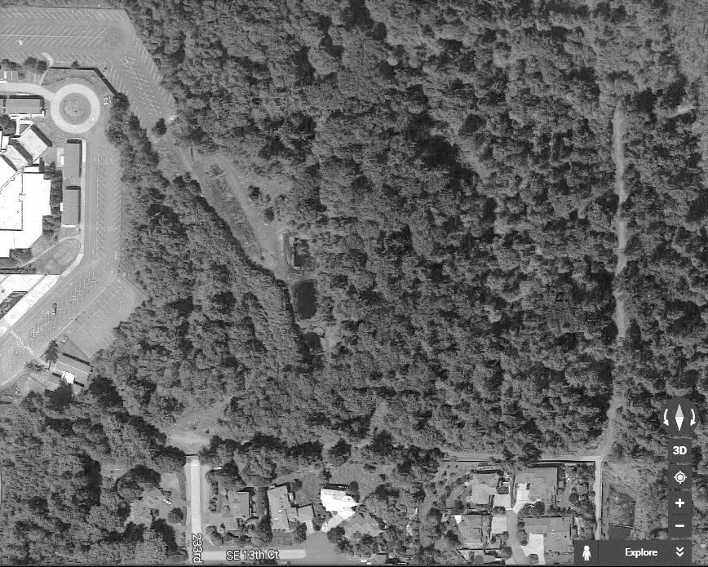

2. Let’s focus on plant communities within these 8 different habitats. Write down the different plants that Ms. Nelson lists in each habitat.

Habitat | Primary Plants | Habitat | Primary Plants
Stream Riparian |  | Alder Grove
Road |  | Grassy Area
Cedar Grove |  | Pond
Mixed Forest |  | Coniferous Forest

3. What if there were only 1 or 2 habitats in the Skyline Forest? How would that affect plant species diversity? How would it affect animal species diversity?

4. The definition of resilient is when an organism is able to withstand or recover quickly from difficult conditions. More diverse ecosystems are able to recover more rapidly, thus they are more resilient. Let’s pretend a disease that affects only Alders spreads to the Skyline Forest and kills all the Alder trees. Which would be more resilient--a Skyline Forest without alders or a Skyline Forest that contains all tree species? Explain your answer.

5. Let’s return to the classroom and watch the following TED talk
https://www.ted.com/talks/suzanne_simard_how_trees_talk_to_each_other
a. Explain, in detail, how Suzanne Simard showed that trees talk to each other.

b. Do trees limit their conversation to only their own species? What 2 species did she use?

c. By what mechanism do trees speak to each other?

d. How do mother trees create a more resilient forest?

e. What does Suzanne Simard mean by a “tipping point” when she says that taking out too many mother trees could cause affect the whole forest?

f. What 4 solutions does she recommend to make logging more sustainable?

