IB ESS Internal Assessment
In the past, the IA for this class was a collection of lab reports. New this year, is ONE full lab report that you create from beginning to end. It is graded on all parts of a lab beginning with a research question that you design and then carry out. Below is how the assessment criteria are graded by both me and the IB Gods. If you are testing in this subject, your IA will go to the IB Gods. Regardless of whether you are testing or not, your IA will go in the lab grade portion of this class. It is the heaviest weighted lab of the year, so, therefore, will have the most impact on your grade for the lab category section.
Identifying the context | Planning (procedure) | Results (raw data), analysis, and conclusion | Discussion and evaluation | Applications | Communication | Total
6 | 6 | 6 | 6 | 3 | 3 | 30
20% | 20% | 20% | 20% | 10% | 10% | 100%

As you look at the criteria on the next pages, notice the difference between how the points are rewarded based on the depth in which you cover the criteria. It is the difference between, for example listing vs. explaining. You should refer to your “IB Glossary of Terms” at the end of this document to make sure that you are meeting the requirements for the command statements (what does outline, state, discuss, explain mean?).
The internal assessment should take you a total of about 10 hours. This includes developing the research question, consultation with the teacher, creating and refining the methodology (procedure) and data collection. You will need to spend additional hours typing up the report, analyzing and concluding.
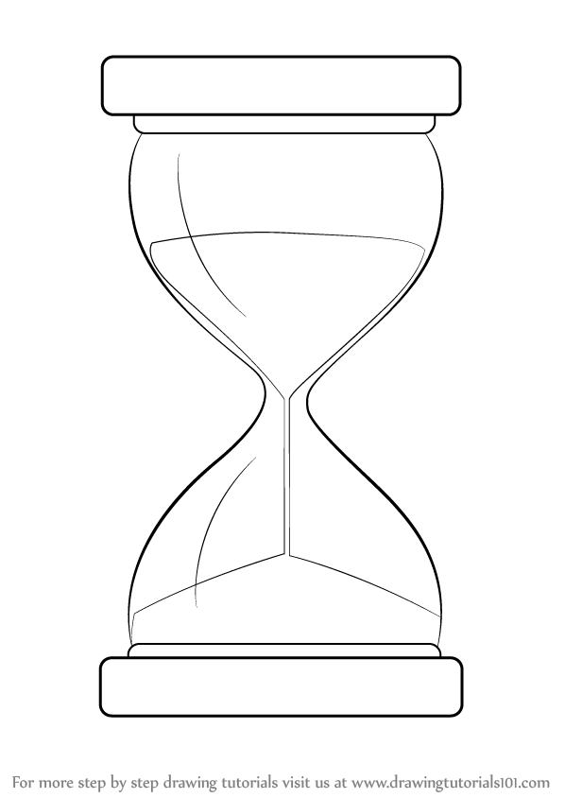
The report should be between 1,500 to 2,250 words long. Your report should not be longer than 2,250 words.
Context of a broad env. issue
Narrow research question and methodology
Discussion of results as it applies to both the research question and the broad env. issue.
The overall structure of the report is that of an hour glass.

1. Identifying the context
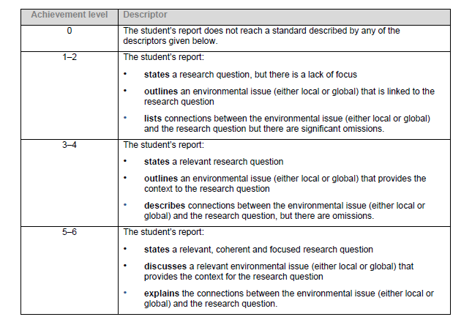
This criterion assesses the extent to which you establish and explore an environmental issue (either local or global) for an investigation and develops this to state a relevant and focused research question.

So to get the top marks here you need to:
- Discuss and explain its global and/or local relevance
- Use to develop a focused/marrow research question
- Explain how the issue is linked to the research question

2. Planning
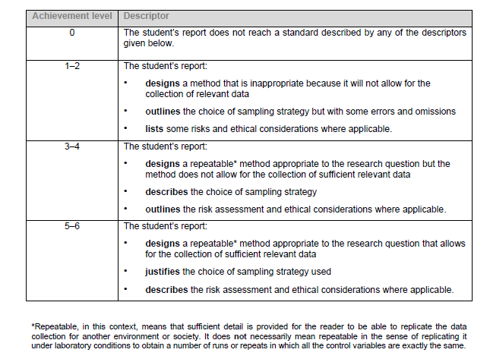
This criterion assesses the extent to which the student has developed appropriate methods to gather data that is relevant to the research question. This data could be primary or secondary, qualitative or quantitative and may utilize techniques associated with either experiential or social science methods of inquiry. There is an assessment of safety, environmental and ethical considerations where applicable.
So to get the top marks here you need to:
- Design an appropriate way to collect enough data to study your research question. Depending on your research question this means you need to do at least 5 levels of manipulations with 5 trials of each manipulation (25 sample points total). For surveys, you would need many more samples that this.
- Explain your method so that someone else could repeat the data collection in another environment.
- Explain why you have used the methods you have used
- Show that you have looked at any ethical issues or risks.

3. Results, analysis and conclusion
This criterion assesses the extent to which you have collected, recorded, processed, and interpreted the data in ways that are relevant to the research question. The patterns in the data are correctly interpreted to reach a valid conclusion.
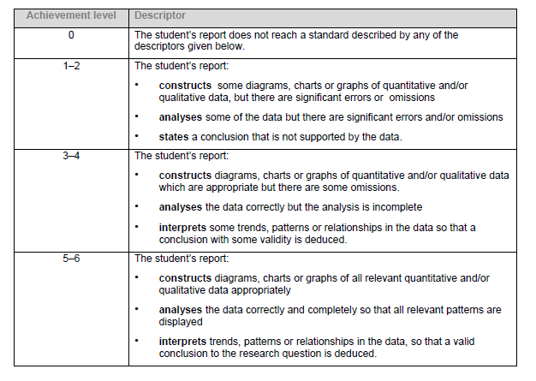
So to get the top marks here you need to:
- Record your data in a way that is clear to everyone else—remember the moderators reading your report do not know as much about the report as you do.
- Present the data in a clear way so that it helps you and others interpret it—remember axes titles and clear labels for everything.
- Spot the trends and patterns and describe and explain them
- Reach a conclusion based on the data—that may not be what you expected.
4. Discussion and evaluation
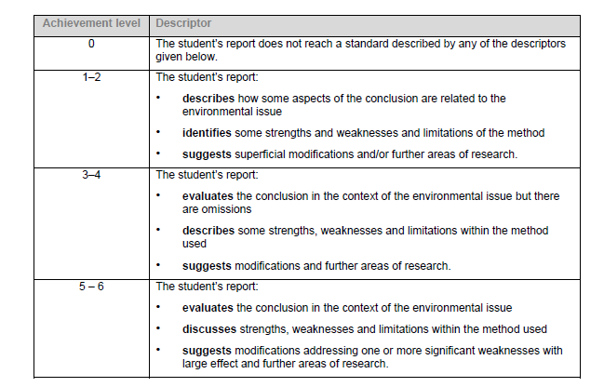
This criterion assesses the extent to which the student discusses the conclusion in the context of the environmental issue, and carries out an evaluation of the investigation.
So to get the top marks here you need to:
- Look at your conclusion and its link to the environmental issue
- Evaluate what you have done—what was good, what was bad, what worked, what didn’t
- Suggest how you could improve your investigation and maybe extend it with further research. The IB Gods DO NOT LIKE it when your improvement is “collect more data points”, or “do more trials”. Instead, it is often helpful to look at which variables were not kept controlled, but could have had an impact on the overall results. Then discuss how you could control the variable for future investigation and why it is important.
5. Application
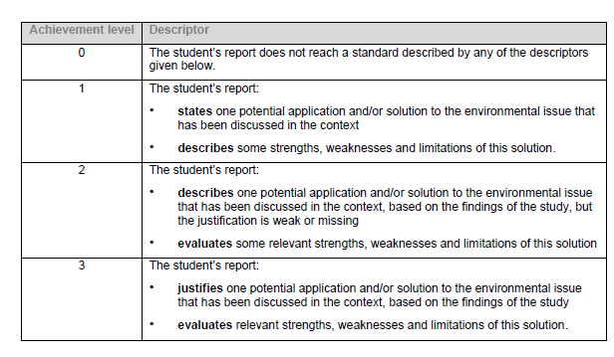
This criterion assesses the extent to which the student identifies and evaluates one way to apply the outcomes of the investigation in relation to the broader environmental issue that was identified at the start of the project.
So to get the top marks here you need to get create and:
- Give one solution to the problem/issue you have studied
- Explain how it would be effective and what problems it many encounter.

6. Communication
This criterion assesses whether the report has been presented in a way that supports effective communication in terms of structure, coherence and clarity. The focus, process and outcomes of the report are all well presented.
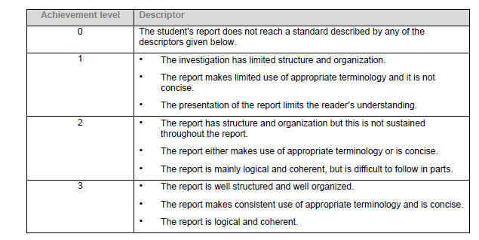
So to get the top marks here you need to think about the reader:
- Be logical and systematic.
- Use page numbers
- Make sure it hangs together well.

The report must be correctly referenced. You will not be penalized for a lack of bibliography or other means of citation, BUT such an omission would probably be treated under the IB Diploma Academic Honesty Policy—this can mean an F on the assignment and the loss of your diploma, if you are a candidate.

