Photosynthesis and Respiration Exploratory Lab
Name:
Partner Name:
Date:

BACKGROUND:
Plants do photosynthesis to store the energy of the sun in glucose as chemical energy. When they need energy for their metabolic processes (such as growth or development), they can use the stored energy in glucose by going though cellular respiration. Plants can (and do) carry out both photosynthesis and respiration simultaneously.

The process of photosynthesis involves the use of light energy to convert carbon dioxide and water into sugar, oxygen, and other organic compounds. The equation for this process is below:

6 H₂O + 6 CO₂ + light energy → C₆H₁₂O₆ + 6 O₂

Cellular respiration is the process of converting the chemical energy of organic molecules into a form immediately usable by organisms. Glucose may be oxidized completely if there is enough oxygen available. The equation for this process is below:

C₆H₁₂O₆ + 6 O₂ → 6 H₂O + 6 CO₂ + energy

All organisms, including plants and animals, do cellular respiration all the time to convert glucose into usable energy. They convert ADP and phosphate into ATP. The energy from ATP is used to:
- Synthesize molecules,
- Move materials around within the organism,
- Grow (create new cells)
- Reproduce.
Notice that in photosynthesis, CO₂ (carbon dioxide) is being used up as it is “fixed” into glucose molecules. During respiration the opposite is true. As the plant releases the energy stored in glucose by breaking it down, CO₂ is being given off into the surrounding water or atmosphere. The relationship between these two processes is special in that it allows plants to recycle some of their by-products. (While CO₂ is being given off during respiration, it can be re-utilized during photosynthesis)

PURPOSE:
In this lab, you will to show the change in oxygen (O₂) and carbon dioxide (CO₂) when spinach leaves are placed in different lighting conditions. You will be using O₂ and CO₂ sensor probes to measure the change in O₂ and CO₂.

UNIT 2 VERNIER PROBEWARE LAB (modified from Vernier Lab 31C, CIBT Elodea Lab and McDougal Littell)

PRELAB QUESTIONS: Use the background information to answer the following questions:

During Photosynthesis:
O₂ is increasing/decreasing.
CO₂ is increasing/decreasing.

During Respiration:
O₂ is increasing/decreasing.
CO₂ is increasing/decreasing.

Figure 1
- On figure one to the right, circle the correct responses in the boxes.

- What is the goal of photosynthesis?

- Write the balanced chemical equation for photosynthesis.

- What happens to the concentrations of O₂ and CO₂ during photosynthesis?

- Which organisms undergo photosynthesis?

- What is the goal of cellular respiration?

- Write the balanced chemical equation for cellular respiration.

- What happens to the concentrations of O₂ and CO₂ during cellular respiration?

- Which organisms undergo cellular respiration?

PACKET SETUP:
Page 1: Title, name, date, partners & Prelab questions
Page 2: Copy the objectives and materials, Draw and label the setups (be sure to read the procedure before drawing!).
Page 3: Data Tables
Page 4: Analysis & conclusion
Page 5: Attach copied graph

OBJECTIVES:
In this experiment, you will
- Use a O₂ Gas Sensor to measure the amount of oxygen gas consumed or produced by a plant during respiration and photosynthesis.
- Use a CO₂ Gas Sensor to measure the amount of carbon dioxide consumed or produced by a plant during respiration and photosynthesis.
- Determine the rate of respiration and photosynthesis of a plant.
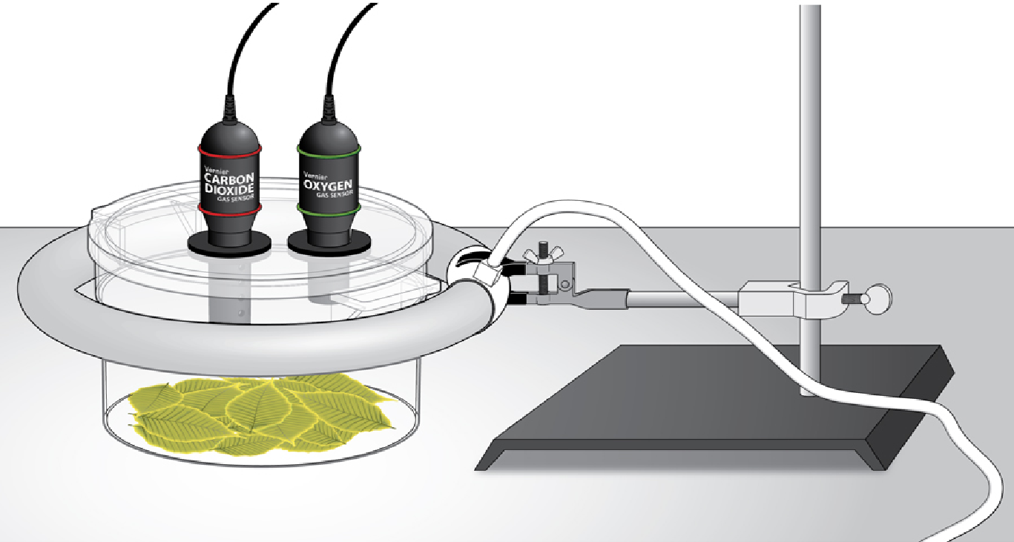
MATERIALS:
1 computer
1 Vernier computer interface
1 Logger Pro®
1 Vernier O₂ Gas Sensor
1 Vernier CO₂ Gas Sensor
1 BioChamber 2000
Aluminum foil-enough to cover chamber
1 12-inch (32.5 cm) ring fluorescent lamp
1 adaptor set up
Spinach leaves-enough to cover the bottom of the chamber with one layer

DIAGRAM OF SET-UPS: using the picture above and the procedure below, draw a diagram of both set-ups. Be sure to include all materials, and label!

In the Dark: | In the Light:
Day 1 PROCEDURE: Exploring Photosynthesis and Respiration using the BioChamber 2000 and Vernier Probes

IMPORTANT: DO NOT TURN THE LAMP ON UNTIL THE PROCEDURE INSTRUCTS YOU TO DO SO.

In the dark:
- Cover the bottom of the chamber with one layer of fresh spinach leaves. Remove any stems that could interfere with an even lining of the bottom.
- Wrap the BioChamber with aluminum foil so that no light will reach the leaves.
  - Cover the lid with foil, poking the holes open to insert the sensors.
  - Secure the lid on the chamber.
  - Wrap the outside of the chamber with foil, wrapping the top end over the top of the lid to the chamber.
- Click on the Logger Pro software that is located on the desktop of the computer.
- Prepare the computer for data collection by opening the file "31C Photo (CO2 and O2)” in the Biology with Vernier folder of Logger Pro. Note: Check the y-axis of both graphs, and make sure that the unit is set to “ppm,” NOT ppt or %.
- Insert the sensors into the holes of your biochamber
- If your CO₂ Gas Sensor has a switch, set it to the low (0-1000 ppm) setting. Connect the CO₂ Gas Sensor to Channel 1 and the O₂ Gas to Channel 2 of the Vernier computer interface.
- Wait 5 minutes to allow the sensors to equilibrate. Move onto step 8 while waiting.
- Set logger pro to collect data of O₂ and CO₂ levels in chamber every 30 seconds, for 15 minutes (refer to logger pro cheat sheet)
- Once sensors have equilibrated for 5 minutes, click to begin the 15-minutes data collection. Make sure to record your data into the data table in your composition book every 30 seconds.
- When data collection is complete, determine the rate of respiration by following steps a-g.
  - Click anywhere on the CO₂ graph

  - Autoscale the data by clicking the Autoscale button on the toolbar
  - Make a best fit line by highlighting the portion of the graph where you see the data values increase.

  - Click on the Linear Fit button to perform a linear regression. A box will appear with the formula for a best fit line.
  - Record the slope of the line, m, as the rate of respiration in your data table. The units will be ppm/min (parts per million/minute).
  - Close the linear regression box by pressing “X” in the upper right hand corner of the box.
  - Repeat Steps 7a-f for the O₂ graph, selecting the region of decreasing O₂ concentration.
- Store your data by choosing “Store Latest Run” from the Experiment menu.
- Label your graphs by following steps a-c below.
  - Choose “text annotation” from “insert” menu
  - Type in “CO₂ in dark” in the edit box located on CO₂ graph, and “O₂ in dark” in the edit box located on the O₂ graph.
  - Drag the line to each box to position it near its respective curve
- Make a screen shot of the graphs (both data sets—CO2 and O2)and email it to yourself at home where you will print it off and include in the analysis.

In the light:
- Locate the Lamp assembly. Do not turn the lamp on until instructed to do so.
- Remove the aluminum foil from the respiration chamber and invert the chamber to remove the leaves and accumulated gases.
- Line the bottom of the chamber with fresh turgid spinach leaves.
- Secure the lid on the chamber and insert the sensors into the holes.
- Place the chamber inside the bulb and plug in the cord to turn on the lamp.
- Repeat steps 3-12 from above to collect and analyze data. NOTE: your previous graphs will still be visible
- Label your new graphs by following steps a-c below:
  - Choose “text annotation” from “insert” menu
  - Type in “CO₂ in light” in the edit box located on CO₂ graph, and “O₂ in light” in the edit box located on the O₂ graph.
  - Drag the line to each box to position it near its respective curve
Take a screen shot of your graphs, paste them onto a word document, and email it to yourself at home
- Clean and dry the chamber. O₂ sensors must be placed in their storage chamber RIGHT SIDE UP!

DATA:
Copy the data from the computer into a data table in your lab packet. The data should include both the CO₂ rate and O₂ rate of production/consumption in ppm/min for both the dark and light set-ups. Make sure you include a title and proper headings with units.
In the Dark In the Light
Title: | Title:
Copy both the CO₂ & O₂ Graphs here | Copy both the CO₂ & O₂ Graphs here

GRAPH:
Take a screen shot of your graphs and email it to yourself. Print the graphs at home and include the printed copy of your graphs as the last page of your lab packet. You should have 4 graphs—CO₂ and O₂ in the light and CO₂ and O₂ in the dark.

ANALYSIS: Answer the following questions in complete sentences
In the dark
- Did photosynthesis occur in the leaves in the dark? Support your answer using evidence from your data table and trends in the graph.

- Did cellular respiration occur in the leaves in the dark? Support your answer using evidence from your data table and trends in the graph.

In the light
- Did photosynthesis occur in the leaves in the light? Support your answer using evidence from your data table and trends in the graph.

- Did cellular respiration occur in the leaves in the light? Support your answer using evidence from your data table and trends in the graph

CONCLUSION: answer the following questions in a paragraph
What did you find out about photosynthesis and respiration in the spinach leaves when put in the dark? What about when placed in the light? Give evidence to support your claim. Give a scientific explanation for why you got the data you got. Include errors (think about variables that were not controlled for during the experiment)

Lastly
Recreate the following table in your science journal, with the title “Scientific Design: Table of factors.” List five factors that might influence the rate of oxygen production or consumption in leaves. Explain how you think each will affect the rate.

Factor | How do you think the factor will affect the rate of oxygen production/consumption?

