**[](http://images.google.com/imgres?imgurl=http://paul.kedrosky.com/WindowsLiveWriter/LerachtheLoraxIMeantNoHarm_A261/lorax_2.jpg&imgrefurl=http://paul.kedrosky.com/archives/2008/06/02/lerach_the_lora.html&h=300&w=276&sz=33&hl=en&start=33&um=1&tbnid=cLNuQPb63Yc0jM:&tbnh=116&tbnw=107&prev=/images?q%3Dthe%2Blorax%26start%3D20%26ndsp%3D20%26um%3D1%26hl%3Den%26safe%3Dactive%26rlz%3D1T4GGLJ_en___US211%26sa%3DN)Notes: Fisheries and Aquaculture**

What should you learn by the end of these notes?

Summarize the case study in the space below.

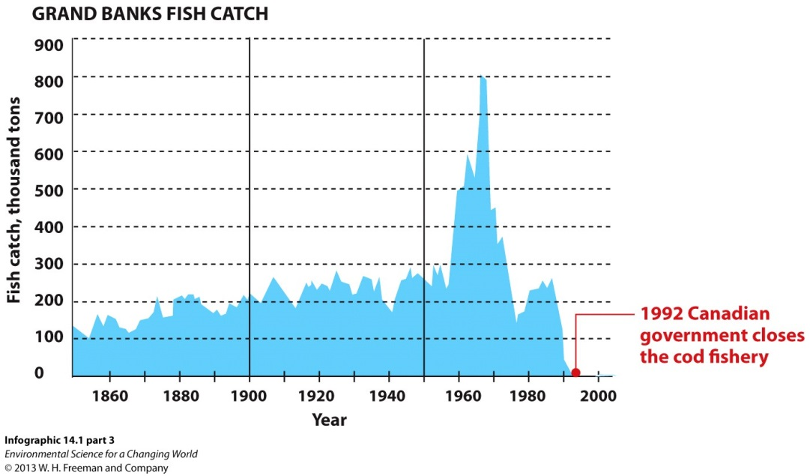

What is a solution to the declining fishing industry?

Looking at the graph to the right what happened to the fish industry in 1990?

Why did this occur?

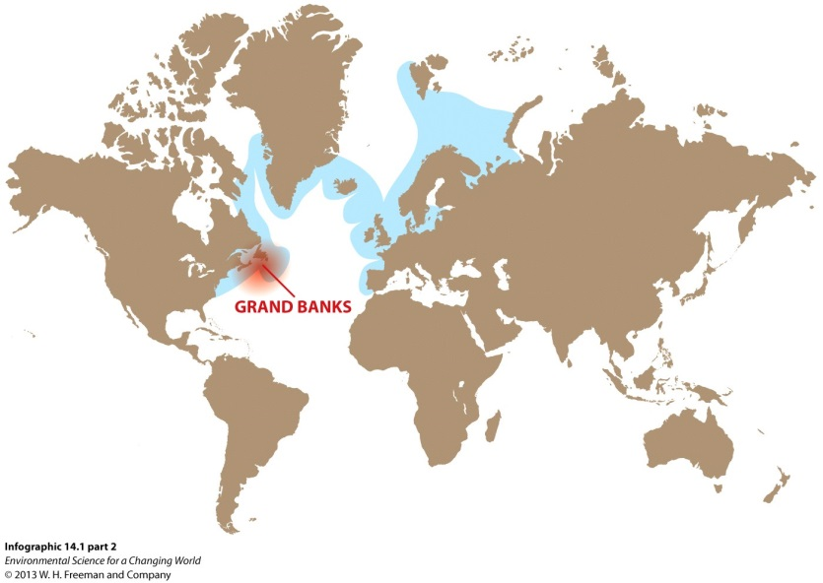

On the map to the left, circle the entire area in which the fish industry collapsed.

When one considers that spawning schools of ________ more than a _____________________________ fish have been observed, it’s hard to imagine that our fishing practices could devastate this population. And yet, they did.

Youtube video on bottom trawling

What kind of fish do the fishermen want to catch in the trawling nets?

Do the fishermen only catch the target species?

Why does the trawler harm the sea floor?

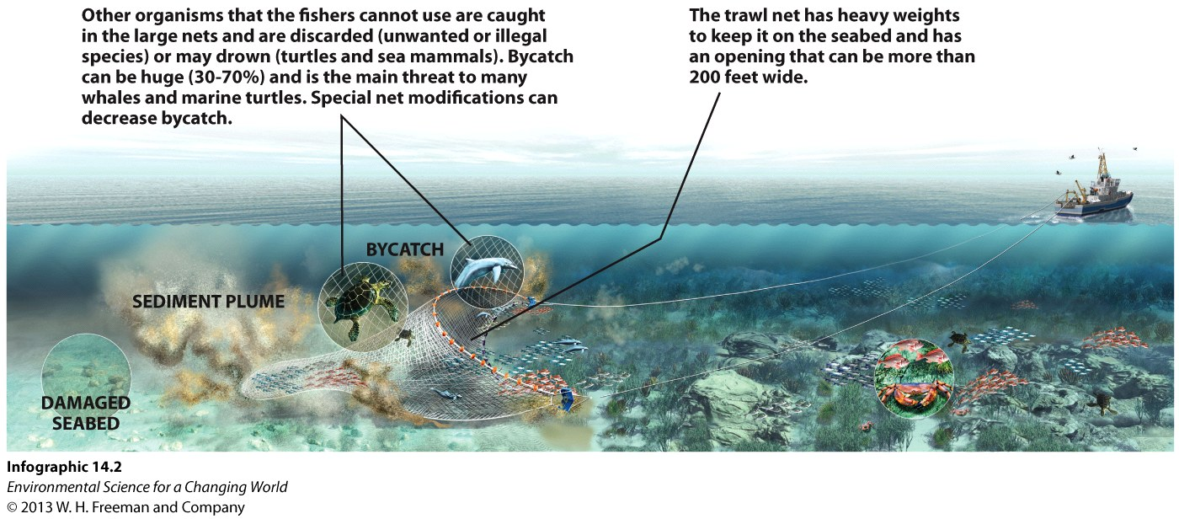

Youtube video on bycatch

What is bycatch?

Name 3 examples of bycatch.

What is a way we can solve this problem?

Humans consume more seafood every year than ________________________________________________________.

Wealthy countries take advantage of the ____________________ while poorer nations get an inexpensive source of ______________________.

More than 200 million people make their livings in the fishing industry, which generates about _____________________ annually.

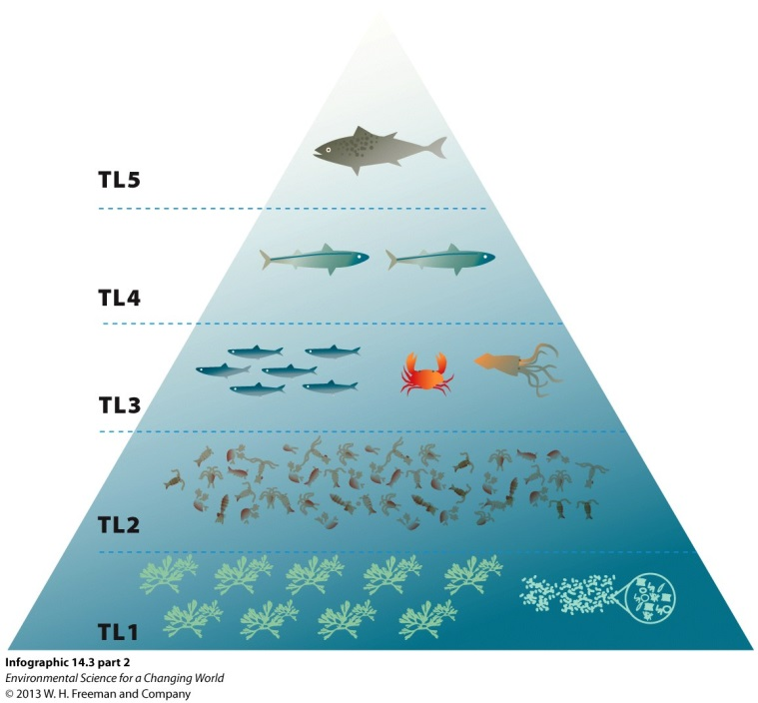What do you think TL5 means?

Which species of fish is most numerous?

Which is least numerous?

What concept teaches the reason for the number of fish at different trophic levels?

Using your reasoning from the answers above, which species of fish is best for fishing?

Say you were at a seafood restaurant and there was crab on the menu or cod on the menu. Which is the most responsible choice to order?

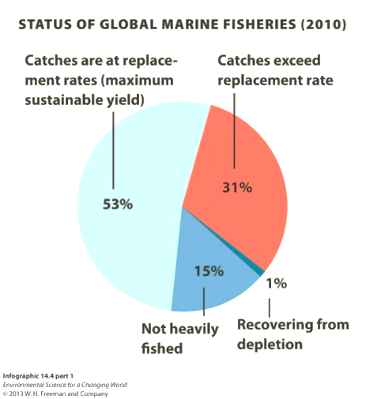What is “fishing down the food chain”?

One obstacle to recovery of cod and other large predatory fish is the ________________________________________. When cod are depleted, fishers pursue the herring, crabs, and other low-order species, _________________________  
______________________________________.

More than _____________the world’s fisheries are at their maximum sustainable yield—fully exploited, the amount that can be harvested __________________________________________________________

___________________.

Another _________________are overexploited or depleted, meaning there are ________________________________  
________________________________________.

With increasing human population (more than 7 billion today and expected 9 billion in 2050) and shifting of diets to less fattening fish, demand for aquatic food supplies will continue to increase.

Magnuson-Stevens Fishery Conservation and Management Act (1976)

Primary law governing marine fisheries in U.S. federal waters.

Amended in 1996 to focus on _____________________________, __________________________, and _____________________________.

Amended in 2006 to add market-based programs like _____________________.

**Marine protected areas (MPAs)** provide varying degrees of protection for different species, depending on the area and need. **Exclusive economic zones (EEZs)** extend 200 nautical miles from the coastline of any given nation, __________________________________________________________________________________________.

With _____________________________________ (more than 7 billion today and expected 9 billion in 2050) and shifting of diets to less fattening fish, demand for aquatic food supplies will continue to increase.

______________________________ (fish farming) is a solution.

Youtube video on aquaculture

Why is traditional fish farming harmful to the environment?

Why is deep ocean fish farming advantageous?

What do fish farmers feed their fish? Does this make ecological sense?

|  |  |
| --- | --- |
| Problems | Solutions |
|  |  |
|  |  |
|  |  |
|  |  |
|  |  |
|  |  |
|  |  |

Today, 85% of the fish consumed in the United State are _________________________________________. Not only does that mean the fish are ___________________, but also that ____________________ are required for ____________________________ and _____________________________.

By ______________________________ through locally grown fish, even in land-locked areas, the footprint associated with fish consumption is _______________________________.