**[](http://images.google.com/imgres?imgurl=http://paul.kedrosky.com/WindowsLiveWriter/LerachtheLoraxIMeantNoHarm_A261/lorax_2.jpg&imgrefurl=http://paul.kedrosky.com/archives/2008/06/02/lerach_the_lora.html&h=300&w=276&sz=33&hl=en&start=33&um=1&tbnid=cLNuQPb63Yc0jM:&tbnh=116&tbnw=107&prev=/images?q%3Dthe%2Blorax%26start%3D20%26ndsp%3D20%26um%3D1%26hl%3Den%26safe%3Dactive%26rlz%3D1T4GGLJ_en___US211%26sa%3DN)Notes: Food Production and Distribution**

Figure 1: Global Food Production

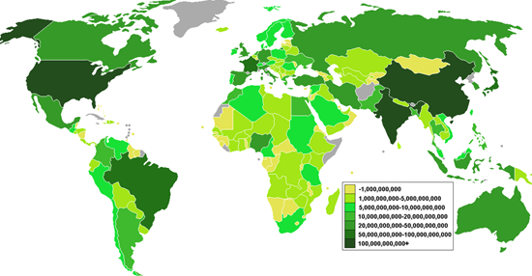

**Compare the 2 maps to the left**.

Which countries produce the most +food?

Which countries produce the least amount of food?

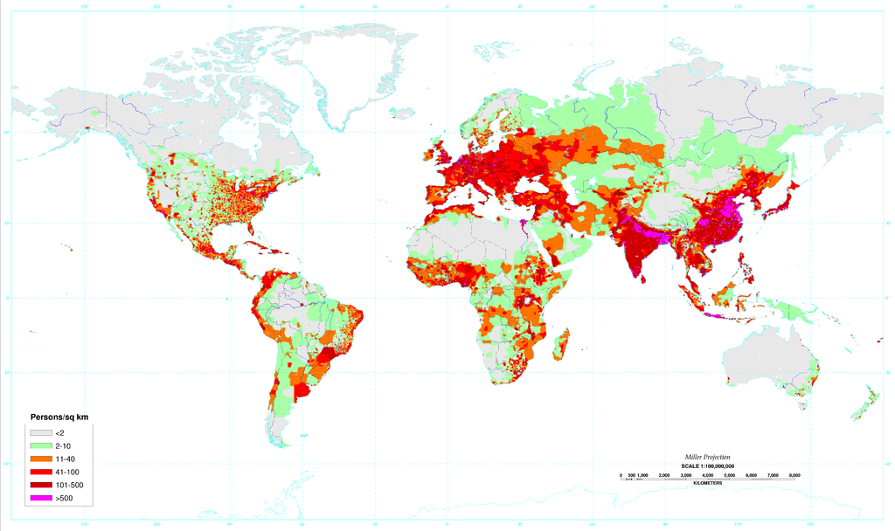 Which countries have the highest population densities?

Figure 2: Global Population Densities

After studying these 2 maps which countries do you think will have a surplus of food which they could export to other countries?

Which countries do you think will have a shortage of food and will most likely import food?

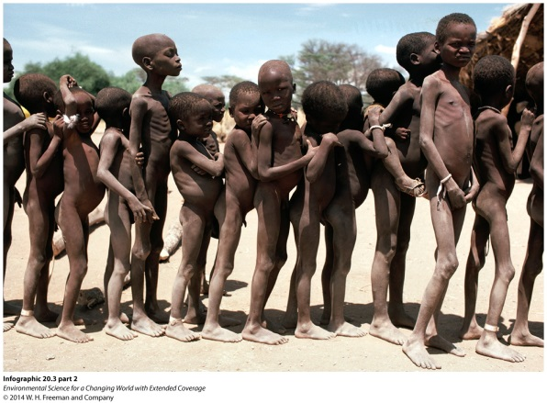

**Malnutrition** is

Symptoms

**Undernutrition** is

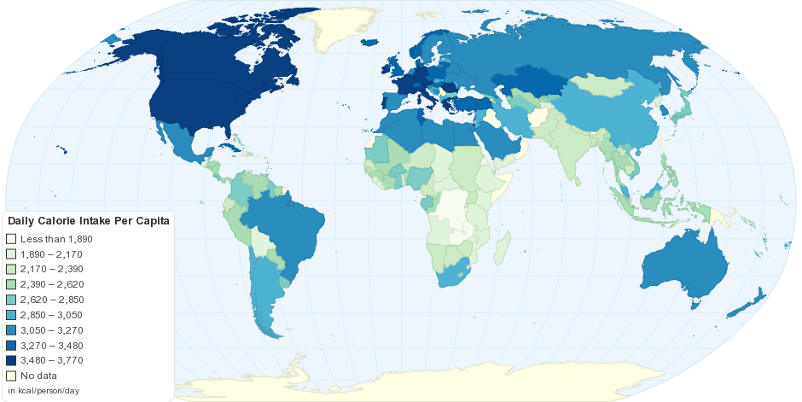Study the key below for the daily calorie intake per person around the globe.

Outline on your map the distribution of low income food deficient countries.

Answer on your own….What are some common factors for these countries?

Answer on your own…What food issues do countries with high per capita calorie consumption face?

|  |  |  |
| --- | --- | --- |
|  | MEDCs | LEDCs |
| Average energy intake: calories per capita per day |  |  |
| Major types of food (% total of calorie intake)  Meat  Fish  cereals |  |  |

* UN FAO (________________________________________________________________) goal:
  + Cut the percentage of people around the world who are underfed by ½.
* __________________________________________
  + All people at all times have physical, social, and economic access to sufficient, safe, and nutritious food.
* While many people around the world are starving to death or are undernourished, others are over fed.
* In the U.S. according to the National Institute for Health
  + More than_________________adults are considered to be overweight or obese.
  + More than ________________ adults are considered to be obese.
  + More than ____________________adults are considered to have extreme obesity.
  + 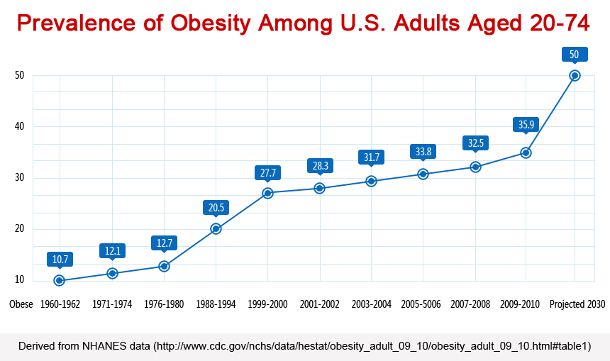About _______________ of children and adolescents ages 6 to 19 are considered to be overweight or obese!

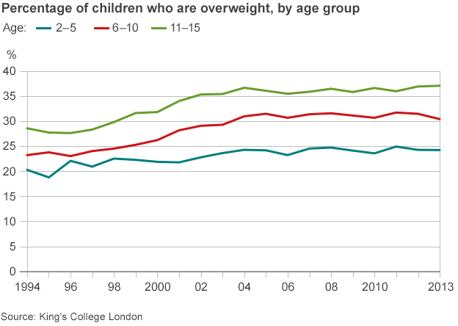

Food Security on MEDCs and LEDCs

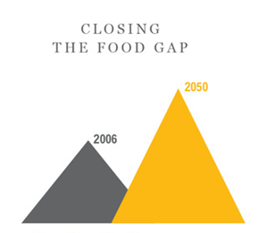What is the great balancing Act?

