What the Stork Says Notes
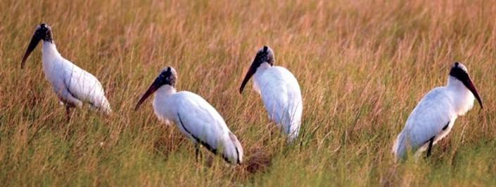
Write the organisms mentioned in the video in the space below

Ecological Terms
Write the definition of each word and give an example for both the Florida Everglades and the Pacific Northwest.
Term | Definition | Examples
Species
Population
Community
Habitat
Ecosystem

Abiotic
Biotic
Niche
Fundamental Niche
Realized Niche
Resilience

Circle and label the picture below with the following terms:

Species
Population
Community
Habitat
Ecosystem
Abiotic
Biotic

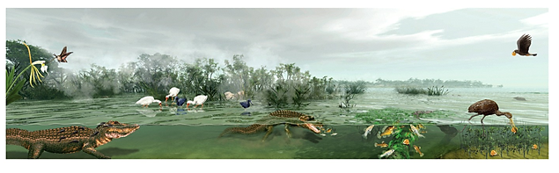
Next we will go outside and find specific examples of each term.
For the Skyline forest write down examples of each term.
Species
Population
Community
Habitat
Ecosystem
Abiotic
Biotic
Draw the Skyline Forest in the space below and label the picture with the terms above

Now let’s head back to the classroom
Community Interactions
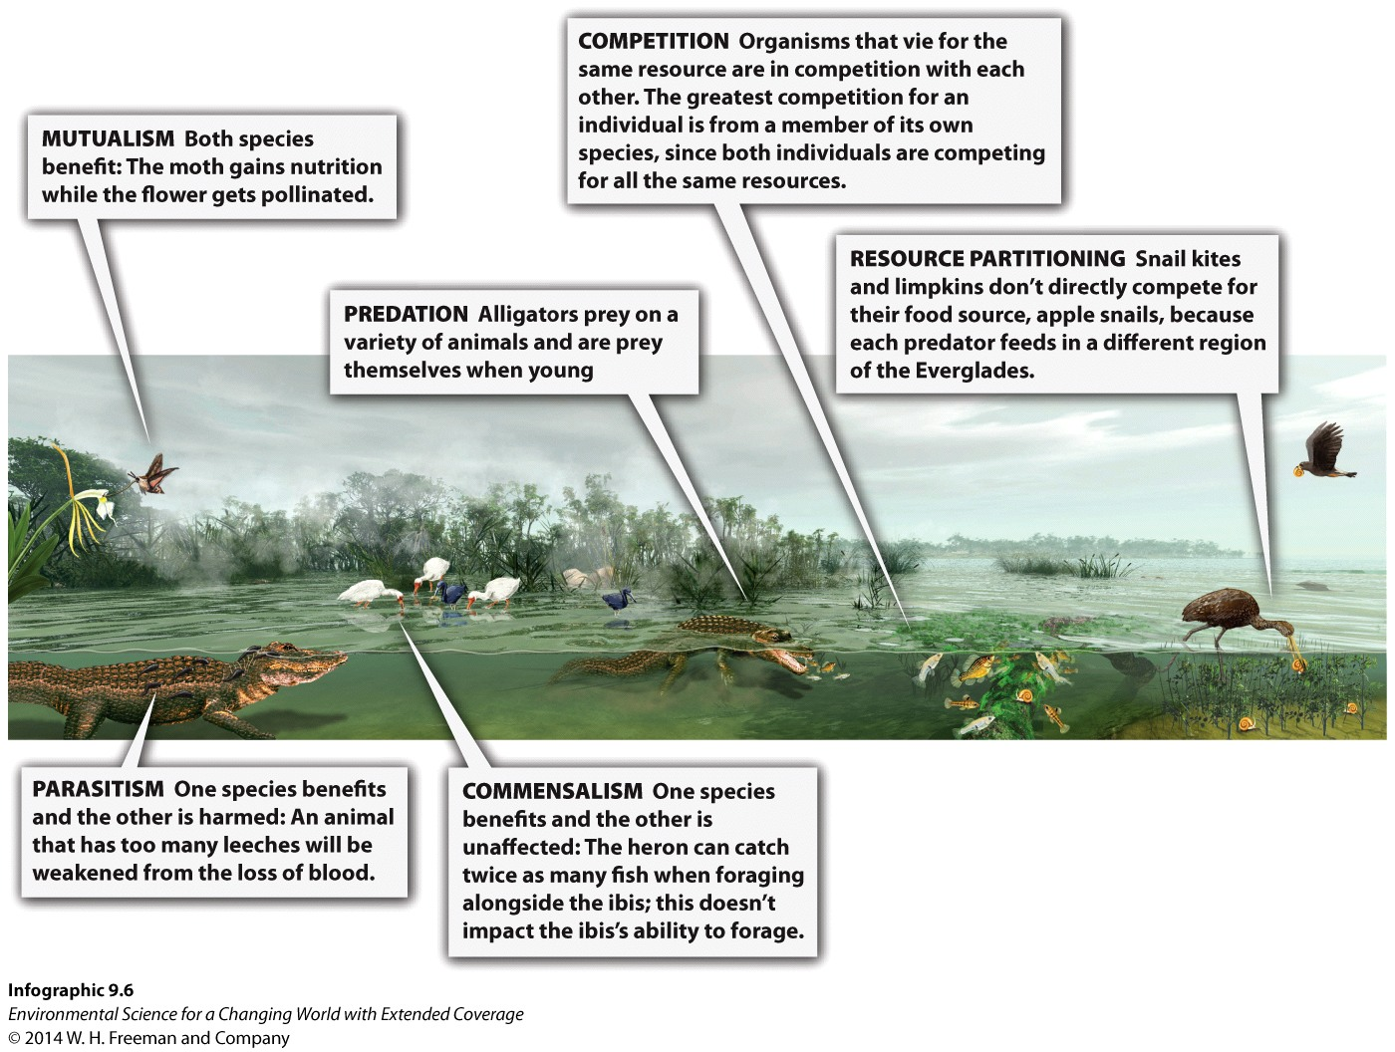
Fill in the chart below based off of the information in the picture above.
Type of Interaction | Brief Description of interaction | Species A (+, -, 0) | Species B (+, _, 0) | Example from Everglade food web
Competition
Predation
Parasitism
Commensalism
Mutualism
Food Chain: ________________________________________________________________________________________
Study the Florida Everglades food web below. Find and circle a food chain that has 5 trophic levels
Label each organism with the terms: producer, primary consumer, secondary consumer, tertiary consumer, quaternary consumer, heterotroph, autotroph, carnivore, omnivore, herbivore.
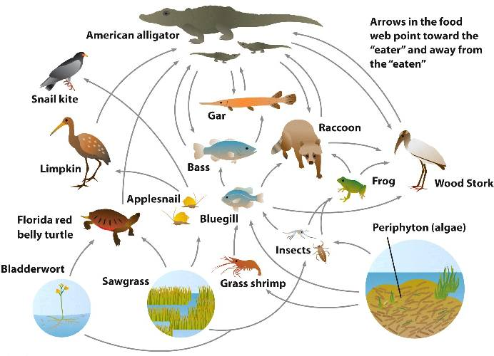
Answer these questions based on the food web above.
1. What is the longest food chain in the food web?

2. Name 2 species that are found at two trophic levels.

3. If all snail kites die, what may happen to (a) apple snails and (b) limpkins?

4. If there is a great increase in the frog population what happens to (a) frog predators and (b) the insects?

5. If a pesticide is added to kill insects, what may happen to the alligators?

6. Add a decomposer and a detritivore to the food web. Include feeding arrows.

