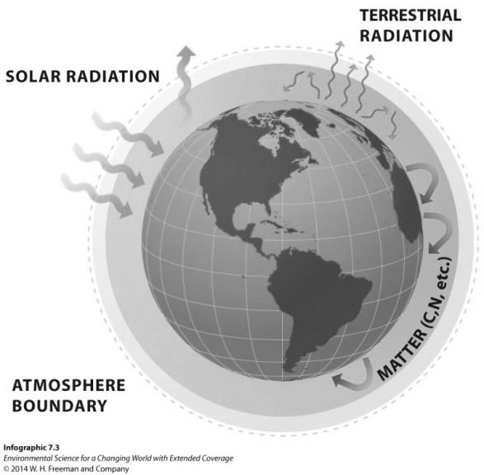
Carbon and Nitrogen Cycles Notes
There is a fixed amount of carbon and nitrogen on Gaia. Since Gaia is a closed system, matter must be recycled just like in Biosphere 2
- How did the scientists in Biosphere 2 ensure that carbon and nitrogen were recycled in the dome?

- Were they successful?

The moral of the Biosphere 2 story is that there is a fine balance to the recycling process of nutrients. Life as we know it has evolved to deal with a certain amount of carbon and nitrogen availability. If that amount changes, then organisms have a hard time surviving.

- What organisms are responsible for recycling nutrients like carbon and nitrogen back into the environment so they can be reused?

CARBON CYCLE
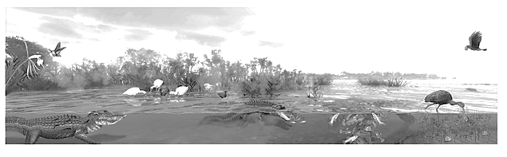
Let’s look at the carbon cycle in the Florida Everglades. Draw arrows showing the path of carbon as it moves through the ecosystem. Draw boxes around carbon sinks (storages) and write transfer and transformation on the arrows.

Let’s do the same thing for our forest ecosystem here in the great Pacific Northwest. Notice that carbon is exchanged among different components of the system. For example carbon is taken up by plants and then transferred to animals that eat the plants. When both the plants and animals die, they are decomposed by organisms in the soil.
- What happens to the carbon once the decomposers are done with their job?
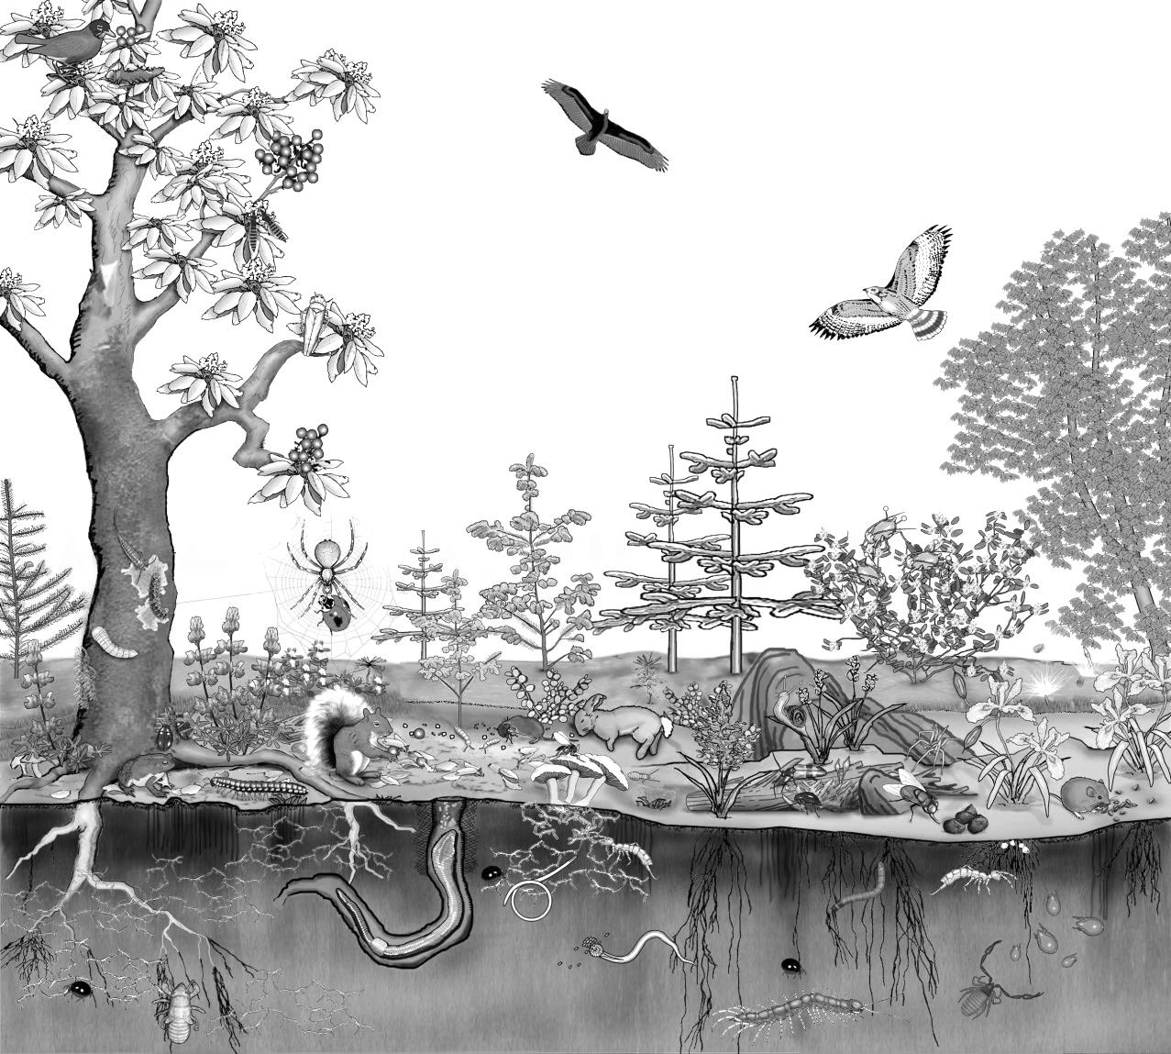

Draw a factory in this scene that burns coal and emits CO₂. Cut down a couple of trees by drawing Xs through them. How do these changes affect the carbon cycle?
NITROGEN CYCLE
- Take a deep breath in. What percentage of air that just went into your lungs was oxygen? What percent was nitrogen? What percent was CO₂?

- Take a deep breath out. What percentage of air that just came out of your lungs was oxygen? What percent was nitrogen? What percent was CO₂?

- Nitrogen is essential to your body for the construction of __________________ and _____________. But we cannot obtain it by breathing it in from the atmosphere. How, then, do we get this essential nutrient into our body?

Using the picture below lets draw the nitrogen cycle using boxes, arrows, and words (transfer and transformation). Notice that nitrogen is exchanged among different components of the system. For example, nitrogen is taken up by bacteria in the soil and then transferred to plants via the roots. Animals then eat the plants and incorporate the nitrogen into their bodies. When both the plants and animals die, they are decomposed by organisms in the soil.
- What happens to the nitrogen once the decomposers are done with their job?

