Specific Heat Notes
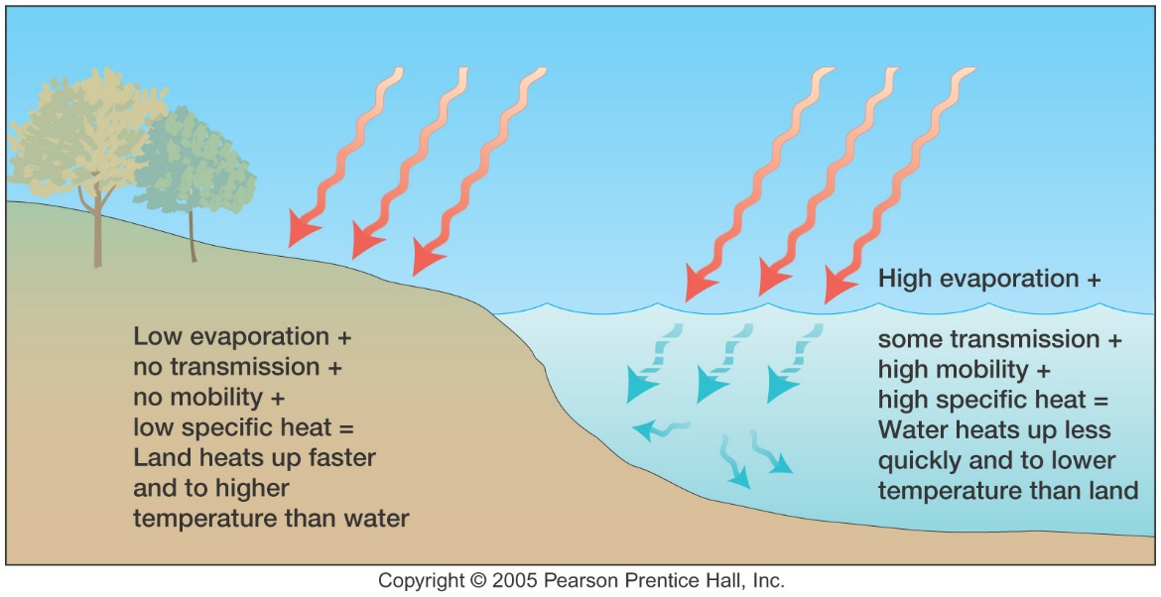
Calculate the difference in temperature for both the average water and sand. Include uncertainties in your calculations. Show your work below.

Compare the 2 temperatures. How much more heat did sand absorb than water?
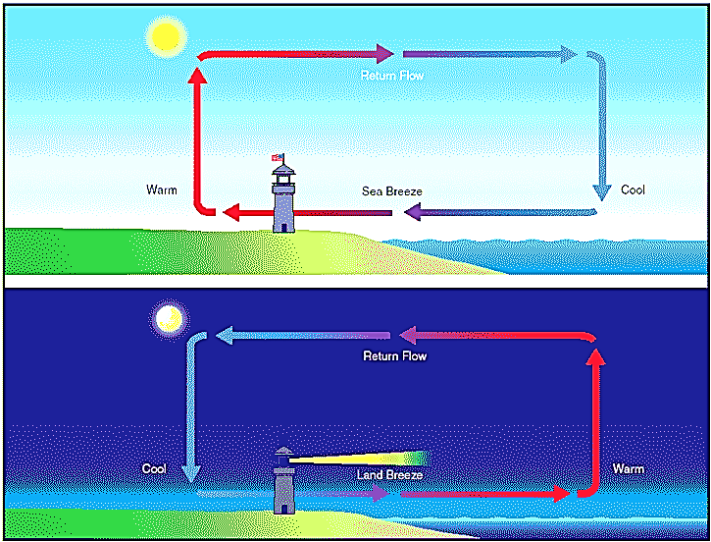
Summarize what is happening in the picture to the right.

Explain why coastal cities are more mild than cities in the interior.

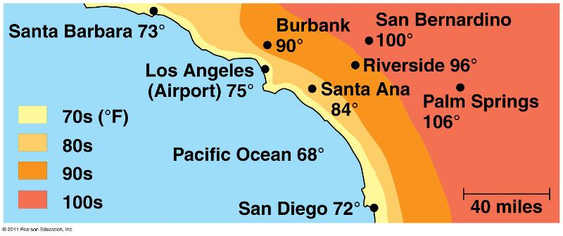

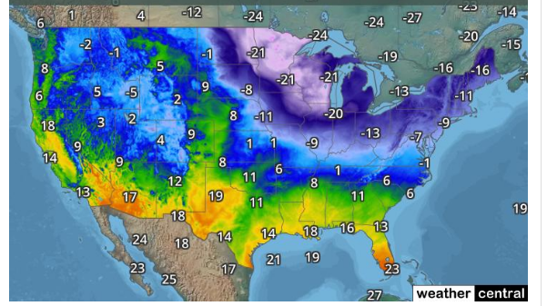
Why is it so much colder in Minnesota and Wisconsin that here in Seattle even though we are located at the same latitude?

Why is it so warm in Texas?

Even though Boston and New York City are on the coasts, why is it so much colder there than in Seattle?

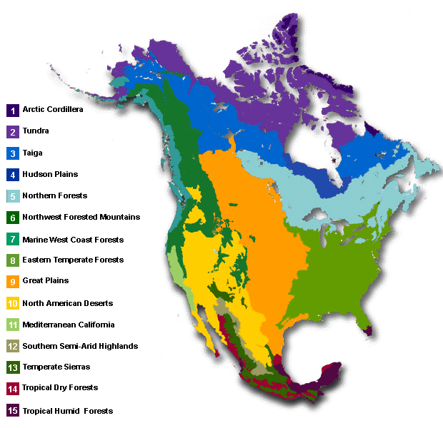
Explain why the biomes are distributed in such a pattern based on the specific heat of soil and water.

