Biodiversity Review Booklet Instructions
CLASS COPY
Page 1:
Copy the following concept map in the first page in your booklet

Biodiversity

Term:
Definition:

Formula:

Formula name:
Term:
Definition:
Term:
Definition:

Page 2:
Draw a limited food web and a diverse food web. Circle the food web that is the most resilient. Why is it the most resilient?
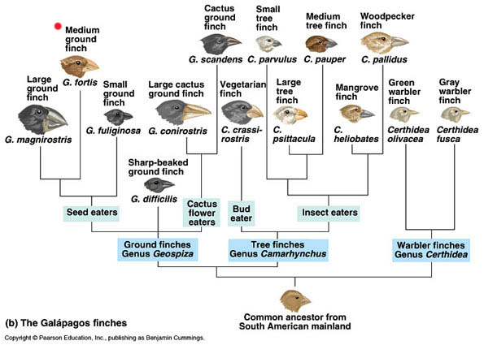
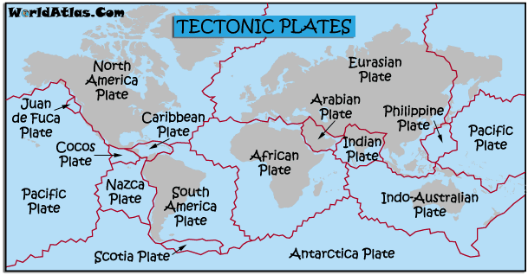
Page 3: Discuss how the 3 pictures below relate to each other and connect these ideas to biodiversity
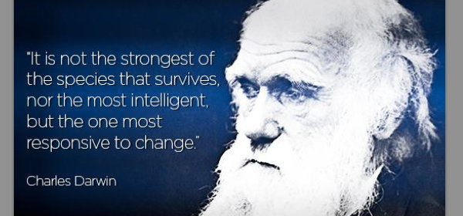

Page 4
Draw a pie graph that shows the reasons for endangerment. Also discuss why it is important to preserve biodiversity.

Page 5: Draw the logo below in your booklet. What does IUCN stand for and what do they do? Discuss in detail how the organization determines levels of risk of extinction and what categories they use. In addition draw 3 or 4 other conservation organization logos
Page 6: Draw the table below comparing the species-based approach with the habitat-based approach. Use vocabulary taught in class.
Conservation Approach | Advantages | Disadvantages
Species-Based
Habitat-Based

