Soils Review Sheet
Soil structure and function
What is soil made up of
identify what is biotic and what is abiotic in soil
Draw and label a diagram of the inputs and outputs of the soil system as it interacts with the atmosphere
List the steps of soil formation starting from parent rock.
Include chemical and mechanical weathering.
Know how to read the soil texture chart
What is the ideal soil for farming and why
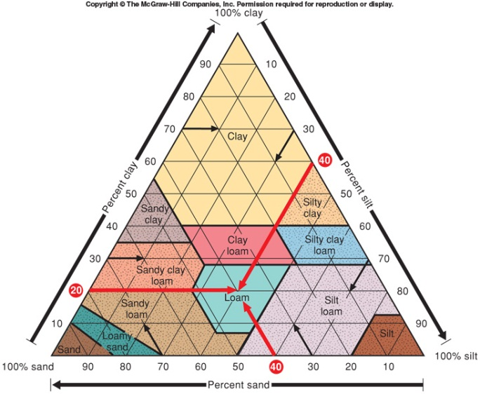
What does arable mean?
Name 2 differences between sand, clay, silt, and loam
What is a soil horizon and why is it important

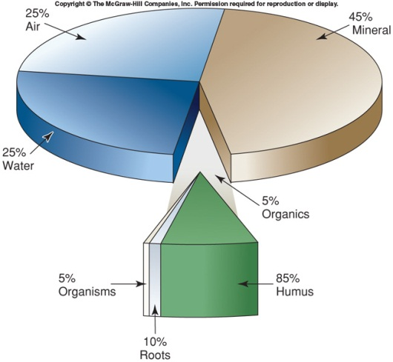
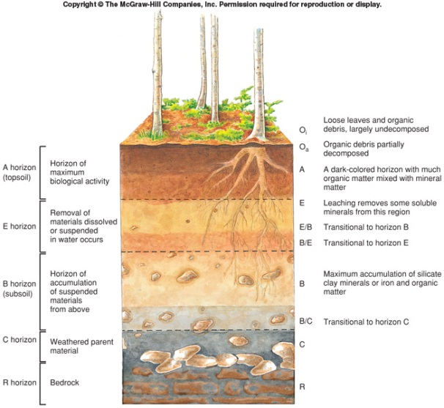

Know the order of the horizons and which type of soil profile you would find in the desert, the forest, and the grasslands.

Farming
Be able to discuss the ways we degrade soil and conversation methods for each
- Erosion
- Toxification
- Salinization

Know the difference between subsistence farming and commercial farming. Be able to name inputs and outputs for each system
Meat consumption and food waste
Which countries eat the most meat?
Using and ecological pyramid, discuss why eating at a lower trophic level is more efficient.
Why is food wasted in More Economically Developed Countries?
Why is food wasted in Less Economically Developed Countries?
What are some solutions to preventing food waste?

