Name ________________________________________Date _____________ Period____
Aquatic Food Webs and Productivity
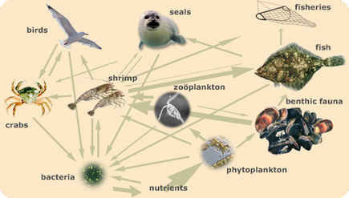

Study the food web above.
1. How many trophic levels does this food web contain?
2. A) Draw the food pyramid for the food web in the space below .

B) Label the trophic levels with the appropriate feeding level name.

C) If the 1st trophic level starts with 34,700 kJ m⁻² yr⁻¹, how productive are the other trophic levels? Label these amounts on your energy pyramid.

3. The Inuit are indigenous aboriginal people of Northern Canada. The data below come from a study of an Inuit fish farming community. The Inuit fish in the open sea but have also sectioned off a large fjord (a narrow inlet of the sea) which they use for farming salmon and shrimps. The shrimps eat microscopic plants in the sea called phytoplankton. Salmon and kawai (a wild fish) both eat shrimps.
 | All units in kJ m⁻² yr⁻¹
Insolation on fjord | 185,000.0
Insolation on open sea | 1,972,000.0
Farmed shrimp consumed by Inuit | 26.0
Gross primary production by phytoplankton | 3,470.0
Shrimp consumed by kawai | 847.0
Respiratory loss by kawai (open sea) | 572.0
Shrimp consumed by salmon (farmed) | 461.0
Respiratory loss by salmon | 410.0
Kawai consumed by Inuit | 6.2
Salmon consumed by Inuit | 4.3
Energy used in managing salmon farm | 4.1
Energy used in managing shrimp farm | 14.0
Energy used in other human activities including trading furs | 12.5

A) Use the data to complete the productivity diagram below.
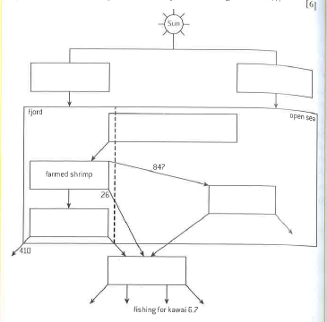

b) (i) Define what is meant by the term gross primary productivity (GPP).
(ii) State how GPP differs from net primary productivity (NPP).

(iii) Identify the factors other than insolation which affect rates of gross primary productivity.

c) Using the data in the table above, determine whether salmon or kawai is more efficient at converting food into biomass.
d) Compare the efficiency of aquatic food production systems with terrestrial food production systems.

e) Calculations based on the data would suggest that farming and eating shrimp is the most energy efficient food source for the Inuit. Suggest why the Inuit continue to farm salmon.

f) Suggest ways in which this indigenous food production system might differ from a large-scale commercial food production.

