Name ________________________________________ Date _________________ Period ___________
Measuring Species Diversity
Species diversity is the number of different species and the relative numbers of individuals of each species.
Ecologists try to express diversity in a number. This makes it possible to compare ecosystems or to see whether ecosystems are changing over time. Quantification of biodiversity is important to conservation efforts so that areas of high biodiversity may be identified, explored, and appropriate conservation put in place where possible. The ability to assess changes to biodiversity in a given community over time is important in assessing the impact of human activity in the community.
The most common way to turn diversity into a number is Simpson’s Diversity Index.
But be careful. The name “Simpson’s Diversity Index” actually describes three related indices (Simpson’s Index, Simpson’s Index of Diversity and Simpson’s Reciprocal Index). Here we are using Simpson’s Reciprocal Index in which 1 is the lowest value (when there would be just one species) and a higher value means more diversity.
D = N(N-1)
∑n(n-1)

where D = diversity index
N = total number of organisms of all species found
n = number of individuals of a particular species

Example:
 | Number of individuals of species
 | A | B | C
Location 1 | 25 | 24 | 21
Location 2 | 65 | 3 | 4
Number of individuals of three species in 2 different locations within an ecosystem, for example, in a mixed coniferous/deciduous forest.

The diversity index of location 1 can be calculated like this:
N = 25 + 24 + 21 = 70

D = 70 (70-1) = 3.07
25(25-1) + 24(24-1) + 21(21-1)

In location 2, the diversity index is:
N = 65 + 3 + 4 = 72

D = 72(72-1) = 1.22
65(65 -1) + 3(3-1) + 4(4-1)

Diversity is a COMPARISON between at least 2 different locations within the same ecosystem or COMPARISON of the same habitat in 2 different time frames. Location 1 has almost triple the amount of diversity than location 2. In this case, both locations have the same species richness (3), but in location 1 these are more evenly distributed (species evenness) so species diversity, by this measure, is higher.

We can only accurately compare 2 similar ecosystems or two communities with an ecosystem. If you tried to compare a tropical rainforest (which is a biodiversity hotspot) with a polar ecosystem, this would not be a fair comparison. Rather you would compare 2 different communities within a rainforest. Or you could compare 2 different communities within a polar ecosystem.

Biodiversity is often used as an indication of ecosystem health. When comparing communities that are similar, low diversity could be indicative of pollution or an invasion of a nonnative species so the number of species present in an area is often indicative of general patterns of biodiversity. What advantage would a high biodiversity bring to a habitat?

But…
High diversity does not always mean a healthy ecosystem.
- Diversity could be the result of fragmentation of a habitat or degradation when species richness is due to a pioneer species invading bare areas quickly—eg. A lawn with lots of different types of weeds
- Some stable and healthy communities have few plant species so are an exception to the rule—eg. Antarctica

Let’s practice using the Simpson’s Diversity Index.

- The following table shows the numbers of each species of organism that were caught in a stream in Sweden in 1992 and in 2001. A new factory was built beside the stream in 1994. Calculate the Simpson’s Diversity Index (the reciprocal form) to determine whether the factory affected the diversity of the stream.

Title: The effect of a new factory on species diversity
Species | 1992 numbers (n) | 1992 n(n-1) | 2001 numbers (n) | 2001 n(n-1)
Mayfly | 8 |  | 16
Dragonfly | 5 |  | 0
Caddis fly | 4 |  | 0
Stone fly | 4 |  | 0
Pond skater | 3 |  | 13
Water louse | 2 |  | 8
Water mite | 1 |  | 0
Flatworm | 4 |  | 0
Roundworm | 3 |  | 0
Leech | 1 |  | 0
Annelid | 2 |  | 0
Snail | 4 |  | 2
Mussel | 1 |  | 0
Water beetle | 0 |  | 3
Stickleback | 0 |  | 8
Water boatman | 0 |  | 7
Damsel fly | 0 |  | 6
Totals N
- Using the data above calculate the diversity for the two different time frames. Write the formula. Show all your work and circle your final answer.

- How does the species richness change from 1992 to 2001?

- Calculate the change in biodiversity levels from 1992 to 2001. Give a quantitative value rather than saying “a lot” or “a little” and show your work

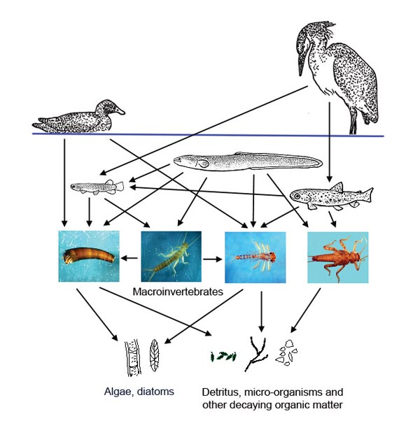
- Study the food web below that shows the role of stream organisms.
Predict what will happen to the food web if 2 if the species of the macroinvertebrates (stream organisms) disappeared in this habitat. Be specific—name organisms—and include trophic levels both above and below the macroinvertabrates.

- Transfer the class data for the cedar soil macroinvertebrate data and the mixed forest macroinvertebrate data to the table below. Don’t forget to include a title.
Title:
Species | alder numbers (n) | alder n(n-1) | Mixed numbers (n) | Mixed n(n-1)
Totals N

- Using the data above calculate the diversity for the two different sets of data. Write the formula. Show all your work and circle your final answer.

- How does the species richness change from the alder data to the mixed data?

- Calculate the difference between the alder forest diversity and the mixed forest diversity by subtracting the diversity numbers you got in (a). Give a quantitative value rather than saying “a lot” or “a little” and show your work.

