Name __________________________________________ Date ________ Period __________

**Productivity Notes and Worksheet**

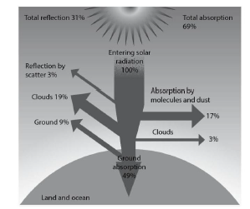The picture below shows the fate of solar radiation reaching the Earth (Gaia). Of all the solar radiation that reaches the earth’s surface, only 0.06% is actually used the photosynthesis process. Photosynthesis is the only way solar energy can be turned into food. (PLANTS ROCK!!!)



CO2 + H2O C6H12O6 (food, sugar) + O2

Plants use this food to stay alive. What is left over is the amount of food available to all the animals including humans.

**Productivity** is the flow of energy from one organism to another. It is also the conversion of energy into biomass over a given period of time. It is measured per unit area per unit time, for example, g m-2 yr-1.

**Gross** refers to the total amount

**Net** refers to the amount left over after deductions.

**Primary** has to do with plants

**Secondary** has to with consumers

**Primary Productivity**

Primary productivity is the productivity at the plant level—the first (primary) level of productivity. The diagram below shows primary productivity in the Florida Everglades food web.



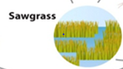

Glucose produced during photosynthesis is called Gross Primary Productivity (GPP)

The remaining glucose is available to be laid down as new material (biomass). This is called Net Primary Productivity (NPP)

Some glucose is used to supply energy to drive cellular respiration

C6H12O6 (food, sugar) + O2 CO2 + H2O + heat energy

GPP – R = NPP

Therefore Net Primary Productivity (NPP) is what is available to consumers to eat. ***NPP is equivalent to the maximum sustainable yield of a system***. In other words if more than the Net Primary Productivity is taken from the system, then the system will be degraded and less will be available for the next time frame.

**Secondary Productivity**

After animals (herbivores) eat plants (NPP), the plant nutrients become assimilated into the body of the animal. This is expressed as the Gross Secondary Productivity (GSP). The Net Secondary Productivity (NSP) is the amount of biomass and energy after cellular respiration and waste. It is what is passed on to the next trophic level. ***NSP is equivalent to the maximum sustainable yield of a system*.** In other words if more than the Net Secondary Productivity is taken from the system, then the system will be degraded and less will be available for the next time frame.

Fill in the blank lines with the following terms: GPP, NPP, GSP, NSP.

Heat loss (due to respiration)

Heat loss (due to respiration)



NSP = GSP - R

GSP = Food eaten - waste

Waste—feces and urine



Heat loss (due to respiration)

Heat loss (due to respiration)

Waste—feces and urine

Waste—feces and urine

As you work your way up the food chain, more and more energy is expended as heat, thus the pyramid shape is an appropriate shape to illustrate this concept. Put in the food chain above into the ecological pyramid below and show where heat is leaving. Also label the pyramid with the terms NPP, GPP, NSP, GSP.

Productivity can also be shown in the following diagram. Circle the correct answer to questions 1-3

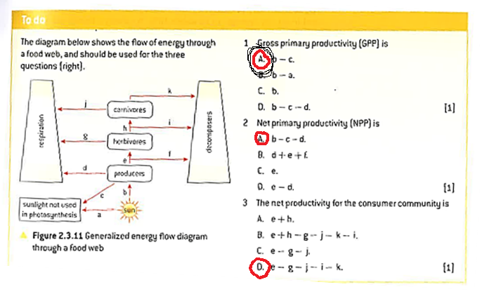

1. Write the equation for photosynthesis:

6CO2 + 6H2O 🡪 C6H12O6+ 6O2

1. Write the equation for cellular respiration. C6H12O6+ 6O2🡪6CO2 + 6H2O

**CALCULATE showing all your work. This means you need to write the equation, plug in the variables, and work the problem. Please include units in both your final answer AND throughout all work shown.** Remember: NPP = GPP – Respirationplants

1. If the GPP for a patch of forest is 10 kg carbon ·m-2·year-1 (same as saying 10kg per meter squared per year), and the amount of carbon dioxide LEAVING the ecosystem is 5 kg carbon·m-2·year-1 due to heat lost via respiration, what is the NPP?

**GPP = 10 kg carbon ·m-2·year-1**

**R = 5 kg carbon·m-2·year-1**

**NPP = GPP -R**

**NPP = 10 kg carbon ·m-2·year-1 - 5 kg carbon·m-2·year-1 = 5 kg carbon·m-2·year-1**

1. In the patch of forest in problem #1, how much energy is available in the primary producer level for herbivore consumption? Assume 1 kg of carbon produces 10,000 kJ.

**(5 kg carbon·m-2·year-1) (10,000 kJ Kg-1) = 50,000 kJ·m-2·year-1**

1. Elodea (an aquatic plant) photosynthesizes and respires in the light, but only respires in the dark (as there is not light to jump start the photosynthesis reaction). Imagine we run an experiment on algae (plant-like organism) *Cladophora glomerata*. We place equal amounts of algae into a light bottle and a dark (covered) bottle. We measure the initial dissolved oxygen in both bottles and find it is at 10 mg/L. We let both bottles sit for a week. In one week, the light bottle has a dissolved oxygen value of 11 mg/L and the dark bottle has a value of 5 mg/L.
   1. What is the purpose of putting algae in light bottles and dark bottles?

**Light bottles = photosynthesis and respiration**

**Dark bottles = respiration only**

1. Explain what happened in this experiment and why it occurred using proper vocabulary learned in this unit.

**Light bottle is more productive than dark bottle.**

**Light bottle NPP =11 mg ·liter-1 - 5 mg ·liter-1 = 6 mg ·liter-1**

**Dark bottle NPP = 5 mg ·liter-**1

1. Imagine we run an experiment on a marine diatom. We place equal amounts of the diatom species in light and dark bottles, and measure their starting wet weight and dry it out. We end up with this data.

|  |  |  |
| --- | --- | --- |
| Week | Wet Weight | Dry Weight |
| Week 1 | 14 grams | 9 grams |
| Week 2 | 19 grams | 11 grams (light bottle) |
| Week 2 | 12 grams | 8 grams (dark bottle) |

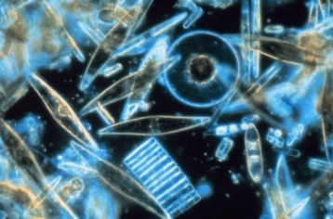

What are the NPP, GPP, and respiration of the species of diatom? Use the dry weights for your calculations. Express your answer in grams per bottle.

**Initial dark bottle (R) = 9 g · bottle-1; after 1 week = 8 g · bottle-1 , so 9 g · bottle-1 – 8 g · bottle-1 = 1 g · bottle-1**

**Initial light bottle (NPP) = 9 g · bottle-1; after 1 week =11 g · bottle-1 - 9 g · bottle-1 = 2 g · bottle-1**

**GPP = NPP +R so 2 g · bottle-1 + 1 g · bottle-1 = 3 g · bottle-1**

1. Which will give you more crops (by weight), a cornfield with a GPP of

5 kg ·m-2·harvest-1 or a wheat-field with a GPP of 10 kg ·m-2·harvest-1? Explain your answer.

**Which crop has more respiration? Not sure. GPP does not tell final production. NPP tells final productivity. Need more information.**

1. Assuming GPP Forest A = GPP Forest B = GPP Forest C, which has the highest rate of respiration in its trees: Forest A, NPP = 1254 J ·m-2·day-1; Forest B, NPP =2157 J ·m-2·day-1; or Forest C, NPP = 779 J ·m-2·day-1? Explain your answer using calculations.

**Forest C since R= GPP-NPP**

**Forest C has the smallest NPP**

1. Which has a higher rate of respiration, Bog A with NPP = 300 g ·m-2·day-1or Bog B with

NPP = 100 g ·m-2·day-1? Explain your answer. **Not enough information to answer the question.**

1. If a forest has a GPP of 200 J ·m-2·day-1and 100 J ·m-2·day-1worth of carbon dioxide flow out of that forest, what is the NPP? Explain your answer.

**GPP = 200 J ·m-2·day-1**

**CO2=R= 100 J ·m-2·day-1**

**NPP = GPP – R so NPP = 200 J ·m-2·day-1 - 100 J ·m-2·day-1= 100 J ·m-2·day-1**

1. If a dark bottle loses 1 g biomass/mL and a light bottle gains 5 g biomass/mL, what is the NPP? What is the GPP? Explain your answer.

**Dark bottle = respiration = 1 g ·ml-1**

**Light bottle = respiration + photosynthesis = NPP**

**NPP = 5 g ·ml-1**

**GPP = NPP + R so GPP = 5 g ·ml-1 + 1 g ·ml-1 = 6 g ·ml-1**

1. The data refer to biomass flows in a freshwater system at 40o N latitude:

|  |  |
| --- | --- |
|  | g.m-2 .yr-1 |
| Gross productivity of phytoplankton | 132 |
| Respiratory loss by phytoplankton | 35 |
| Phytoplankton eaten by zooplankton | 31 |
| Fecal loss by zooplankton | 6 |
| Respiratory loss by zooplankton | 12 |

Heat loss

Zooplankton

Dead remain, feces, etc.

Salmon

Shrimp

Decomposers

Phytoplankton

Respiratory loss

Energy input

Dead remains, feces, etc

sun

A) From the data in the table and with the aid of the diagram, write down equations and calculate:

1. Net productivity of phytoplankton **NPPB1 = E1 – R1**

**GPP = 132 g·m-2·year-1**

**R = 35 g·m-2·year-1**

**NPP = GPP – R**

**NPP = 132 g·m-2·year-1 – 35 g·m-2·year-1 = 97 g·m-2·year-1**

1. Gross productivity of zooplankton

**GSPB2 = E2-D2**

**GSP = food eaten – fecal loss**

**Food eaten = 31 g·m-2·year-1**

**Fecal loss = 6 g·m-2·year-1**

**GSP = 31 g·m-2·year-1 - 6 g·m-2·year-1 = 25 g·m-2·year-1**

1. Net productivity of zooplankton

**NSPB2 = E2 – D2 –R2**

**NSP = GSP - R**

**GSP = 25 g·m-2·year-1**

**R =12 g·m-2·year-1**

**NSP = 25 g·m-2·year-1 - 12g·m-2·year-1 = 13 g·m-2·year-1**

1. % assimilation of zooplankton

**Zooplankton eats 31 g·m-2·year-1 plankton but poops out 6 g·m-2·year-1 and respires 12 g·m-2·year-1 so it loses 18 g·m-2·year-1**

**31 g·m-2·year-1 - 18 g·m-2·year-1 = 13 g·m-2·year-1 ; so 13 divided by 31 = 42%**

1. % productivity of zooplankton

**GSP = 25 g·m-2·year-1 ; so 13 divided by 25 is 52%**

(B) Refer to the diagram to explain why the storage boxes reduce in size as you go up the food chain.

**Less and less biomass is available at each level due to the 10% rule which states that 90% of mass is lost while only 10% is passed to the next level. Biomass is lost during respiration.**

(C) How do the decomposers lose heat?

**Decomposers also have a metabolism (cellular respiration) so they lose heat as well, just like the heterotrophs and autotrophs.**