Name ___________________________________________ Date _________ Period __________
Environmental Science for a Changing World
Chapter 9 Community Ecology: What the Stork Says
Vocabulary Term | Definition | Specific example from:
Community | All the populations (plants, animals, and other species) living and interacting in an area | Everglades—  Pacific Northwest (PNW)--
Indicator species | Species that are particularly vulnerable to ecosystem perturbations, and that, when we monitor them, can give us advance warming of a problem. | Everglades—  Pacific Northwest (PNW)--
Ecosystem | All of the organisms in a given area plus the physical environment in which they interact
Food chain | A simple, linear path starting with a plant (or other photosynthesizer) that identifies what each organism in the path eats. | Everglades—  Pacific Northwest (PNW)--
Food web | A linkage of all the ________________________  ________________ that shows the many connections in the community.
Producer (AKA autotroph) | A photosynthetic organism that captures solar energy directly and uses it to produce its own food (sugar). | Everglades—  Pacific Northwest (PNW)--
Consumer (AKA heterotroph) | An organism that eats other organisms to gain energy and nutrients; includes animals, fungi, most bacteria. | Everglades—  Pacific Northwest (PNW)--
Trophic levels | Feeding levels in a food chain | Everglades—  Pacific Northwest (PNW)--
Detritivores | Consumers (including worms, insects, crabs, etc.) who eat dead organic material | Everglades—  Pacific Northwest (PNW)--
Decomposers | Organisms such as bacteria and fungi that break down organic matter all the way down to constituent atoms or molecules in a form that plants can take back up. | Everglades—  Pacific Northwest (PNW)--
Gross primary productivity | A measure of the _________________________  _________________ captured via photosynthesis and transferred to organic molecules in an ecosystem.
Net primary productivity | A measure of the _________________________ captured via photosynthesis and ________________________ in the photosynthetic organism.
Niche | The role a species plays in its community, including things like how it gets its energy and nutrients, what habitat requirements it has, and which other species and parts of the ecosystem it interacts with. | Everglades—  Pacific Northwest (PNW)--
Habitat | The __________________________________ in which individuals of a particular species can be found. | Everglades—  Pacific Northwest (PNW)--
Resilience | The ability of an ecosystem to __________________ when it is damaged or perturbed.
Species diversity | The_______________ of species in an area; includes measures of species richness and evenness.
Species richness | The total _______________________of different species in a community.
Species evenness | The relative_______________________ of each species in a community.
Keystone species | A species that impacts its community more than its mere abundance would predict. | Everglades—  Pacific Northwest (PNW)--
Competition | Species interaction in which individuals are vying for limited resources. | Everglades—  Pacific Northwest (PNW)--
Symbiosis | A close biological or ecological relationship between _______________________________. | Everglades—  Pacific Northwest (PNW)--
Mutualism | A symbiotic relationship between individuals of two species in which both parties benefit. | Everglades—  Pacific Northwest (PNW)--
Commensalism | A symbiotic relationship between individuals of two species in which one benefits from the presence of the other but the other is unaffected. | Everglades—  Pacific Northwest (PNW)--
Predation | A symbiotic relationship between individuals of two species in which one benefits and the other is negatively affected. | Everglades—  Pacific Northwest (PNW)--
Parasitism | A symbiotic relationship between individuals of two species in which one benefits and the other is negatively affected (a form of predation). | Everglades—  Pacific Northwest (PNW)--
Ecological Succession | _________________________________ of plant (and then animal) species in a community over time due to the changing conditions that the plants themselves create (more soil, shade, etc.)
Primary succession | Ecological succession that occurs in an area where no ___________________existed before (for example, on bare rock with no soil).
Pioneer species | Plant species that move into an area during early stages of succession; these are often r species and may be annuals, species that live one year, leave behind seeds, and then die. | Everglades—  Pacific Northwest (PNW)--
Secondary succession | Ecological succession that occurs in an ecosystem that has been disturbed; occurs _____________  ______________ than primary succession because soil is present.
Climax species |  | Everglades--  Pacific Northwest--
Climax community |  | Everglades--  Pacific Northwest--

- How do wetlands such as the Everglades provide water management? Be specific.

- How have humans impacted the Everglades? Be specific

- Find a picture of a wood stork and draw it in the space below.

- What makes the wood stork a good indicator species?

- What types of ecosystems make up the Everglades?

- How many Wood Storks lived in and around the Everglades in the 1930s?

- How many Wood Storks lived there just 50 years later?

- What did people do to the Everglades starting in 1948?

- Study the food web below. Do the following to the food web:
- Circle a food chain that has at least 5 organisms
- Label the producers, 1st consumers, 2nd consumers, 3rd consumers, 4th consumers
- Circle the Wood Stork. Write the trophic level(s) in which it feeds next to the circle.
- Circle the raccoon. Write the trophic level(s) in which it feeds next to the circle.
- Add detritivores and decomposers to the food web
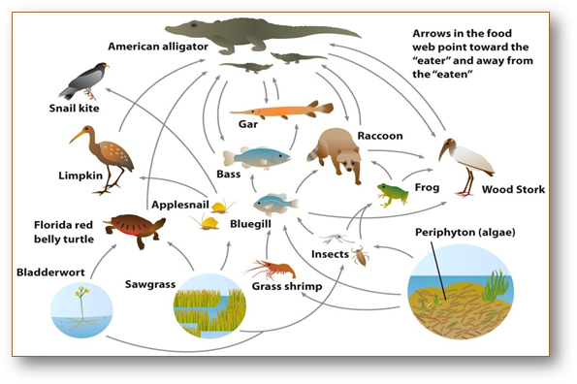

- Draw a pyramid of biomass for the Everglades food web (see page 150). Label the pyramid with the following:
- Producer, 1st consumers, 2nd consumers, 3rd consumers, 4th consumers
- Start the producer level with 631,478 kg/m². Calculate the biomass for each trophic level up to the apex.

- Describe the niche of the Wood Stork.

- How is niche and resilience related?

- Identify the keystone species in the Florida Everglades and explain why this species is so important to the wetland. Be specific.

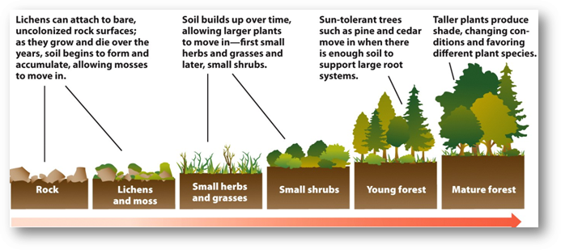
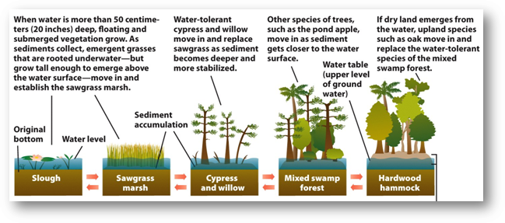
- Study the 2 pictures below. What is the phenomenon called where a disturbed ecosystem grows into a climax community?

